Real-Time Fugitive Criminal Identification Using Deep Learning


SUBMITTED BY:
Muhammad Abu Bakar F19-BSCS-5046
Muhammad Awais Jameel F19-BSCS-5118
Abdullah Shafique F19-BSCS-5028

A Project Report submitted to the
DEPARTMENT OF COMPUTER SCIENCE & INFORMATION TECHNOLOGY
in partial fulfillment of the requirements for the degree of
BACHELOR OF SCIENCE IN COMPUTER SCIENCE

Department of Computer Science
UNIVERSITY OF OKARA
September 2023

DEDICATION
Final year project report submitted to Okara University in partial fulfillment of bachelor’s degree requirements in Computer Science. Our application is dedicated to our parents, and we would especially like to dedicate this project to our project advisors as they guided us in the right direction and gave them valuable time to complete this project. We discussed our project with them, and they gave better suggestions to improve our project.

DECLARATION
It is hereby declared that this project "Real-Time Fugitive Criminal Identification Using Deep Learning" is an original part of my own work, except were acknowledged in the text and references. This work has not been submitted for any other degree or diploma for tertiary education at any university or other institution, nor will it be submitted for any future degree from that or any other university or institution.

Muhammad Abu Bakar
F19-BS(Hons)CS-5046

Abdullah Shafique
F19-BS(Hons)CS-5028

Muhammad Awais Jameel
F19-BS(Hons)CS-5118

September 2023
CERTIFICATE OF APPROVAL
It is certified that the project titled “Real-Time Fugitive Criminal Identification Using Deep Learning” carried out by Muhammad Abu Bakar, Abdullah Shafique, Muhammad Awais Jameel, Reg. No. F19-BS(Hons)CS-5046, F19-BS(Hons)-5028, F19-BS(Hons)-5118, under the supervision of Dr. Riaz-Ul-Amin, is fully adequate, in terms of scope and quality, as a final year project for a Bachelor of Computer Science degree.

Supervisor: -------------------------
Dr. Riaz-Ul-Amin
Chairperson
Dept. of Computer Science
UNIVERSITY OF OKARA

Co-supervisor: -------------------------
Dr. Javed Rasheed
Network Administrator
UNIVERSITY OF OKARA

Internal Examiner 1: -------------------------
Ms. Ifrah Parveez
Lecturer
Dept. of Computer Science
UNIVERSITY OF OKARA

Project Coordinator: -------------------------
Mr. Ahmad Nazir
Lecturer
Dept. of Computer Science
UNIVERSITY OF OKARA

Chairperson: -------------------------
Dr. Riaz-Ul-Amin
Chairperson
Dept. of Computer Science
UNIVERSITY OF OKARA

ACKNOWLEDGMENT
In the name of Allah, the Most Merciful Alhamdulillah, all praises are due to Allah for the strength and His blessings to complete this. We are grateful to our project guide Dr. Riaz-Ul-Amin for his guidance, motivation, and constructive suggestions which helped us in preparing this project. Our acknowledgment also goes to all technical experts and office staff for their support. Heartfelt thanks to all my friends and indirect contributors to this research, your kindness means a lot.

ABSTRACT
This project was initiated in response to the increasing challenges faced by law enforcement and the need for tools to combat activities. The main goal was to address the limitations of methods used for identifying criminals, which often lack real time accuracy and efficiency. To bridge this gap and contribute to law enforcement’s capabilities we pursued a solution using deep learning technologies.
Our approach focused on harnessing the power of deep learning algorithms to develop a web-based system that can identify criminals in time. We created a dataset consisting of images of known fugitives and trained a cutting-edge deep learning model called YOLOv8 on this dataset. This enabled the model to learn facial features and patterns that distinguish individuals. The model was then integrated into a user web interface allowing for real time identification through video input.
After conducting experimentation and validation we achieved promising results with our web-based system. It demonstrated a level of accuracy in identifying individuals from input images. This breakthrough provides law enforcement agencies with a tool that enables accurate identification of suspects in real time scenarios ultimately enhancing their efficiency and effectiveness. The success of this project not showcases the potential of learning in criminal identification but also highlights its practical implications for enhancing public safety.

Table of Contents
DEDICATION ii
DECLARATION iii
ACKNOWLEDGMENT v
ABSTRACT vi
Chapter 1 1
INTRODUCTION 1
1.1 Overview 1
1.2 Statement of Problem 1
1.3 Purpose of the research 1
1.4 Applications of the research 2
1.5 Theoretical bases and Organization 2
1.6 Summary 2
Chapter 2 3
LITERATURE REVIEW 3
2.1 Related Technologies 3
2.2 Related Projects 4
2.3 Related Studies 5
2.4 Their Limitations and Bottlenecks 5
2.5 Summary 5
Chapter 3 7
TOOLS AND TECHNIQUES 7
3.1 Hardware used with technical specifications. 7
3.2 Software(s), simulation tool(s) used. 8
3.3 Summary 11
Chapter 4 12
METHODOLOGIES 12
4.1 Analysis procedures 12
4.2 Design of the investigation 16
4.3 Implementation procedure 31
4.4 Verification of functionalities 33
4.5 Simulation / mathematical modeling 35
4.6 Summary 44
Chapter 5 45
SYSTEM TESTING 45
5.1 Objective testing 45
5.2 Usability Testing 46
5.3 Software Performance Testing 46
5.4 Compatibility Testing 47
5.5 Load Testing 48
5.6 Security Testing 49
5.7 Installation Testing 50
5.8 Test Cases 50
5.9 Testing Environment: 52
Chapter 6 54
RESULTS AND CONCLUSION 54
6.1 Presentation of the findings 54
6.2 Discussion of the findings 55
6.3 Limitation 56
6.4 Recommendations 56
6.5 Summary 57
6.6 Conclusion 57
Chapter 7 58
FUTURE WORK 58
REFERENCES 59

LIST OF FIGURES
Figure 1:Related Technology 4
Figure 2:Device Specification 7
Figure 3:Waterfall Model 14
Figure 4:Use Case Terminology 18
Figure 5:Use Case of Head-Admin 19
Figure 6:Use Case of Admin 21
Figure 7:Use Case of User 22
Figure 8:Initial state or start point 24
Figure 9:Activity or Action state 24
Figure 10:Action Flow 24
Figure 11:Object Flow 24
Figure 12:Decision and Branching 25
Figure 13:Decision and Branching 26
Figure 14:Decision and Branching 27
Figure 15:Sequence Diagram 28
Figure 16:Entity Relationship Diagram 29
Figure 17:Incremental Model 30
Figure 18:Database Table 35
Figure 19:Admin Login 35
Figure 20:Head-Admin Dashboard 36
Figure 21:Register Admin 37
Figure 22:View all Admins 37
Figure 23:Admin Dashboard 38
Figure 24:Register User 39
Figure 25:Admin Reset/Change Password 39
Figure 26:Admin Forget Password 40
Figure 27:User Login 41
Figure 28:User Forget Password 41
Figure 29:User Dashboard 42
Figure 30:Fugitive Criminal Page 42
Figure 31:User Change E-mail 43
Figure 32:User Reset/Change Password 43
LIST OF TABLES
Table 1:Use Case of Head-Admin 19
Table 2:Use Case of Admin 21
Table 3:Use Case of User 23
Table 4:Details about Hardware 31
Table 5:Test Cases 51
Table 6:Test Cases of Admin 51
Table 7:Testing Environment 52

Chapter 1

INTRODUCTION
The main objective of this project is to utilize technology to improve the efforts of law enforcement in identifying and capturing criminals. Using a web-based solution this project employs cutting edge learning techniques to analyze images in time. This provides law enforcement agencies with an accurate tool for identifying individuals who’re on the run. By merging the strengths of web development and deep learning this project contributes to the modernization of criminal identification processes ultimately resulting in communities and effective law enforcement practices.

1.1 Overview
Introducing a groundbreaking approach called Real Time Fugitive Criminal Identification Using Deep Learning that combines web technology and advanced deep learning algorithms. This revolutionary solution aims to transform the process of identifying and tracking down criminals. By utilizing real time video analysis law enforcement agencies can swiftly and accurately identify individuals who're of interest. The system is web based allowing access from devices and locations ultimately enhancing the speed and effectiveness of criminal identification efforts.

1.2 Statement of Problem
In the field of law enforcement one of the challenges is catching fugitive criminals in a timely manner. Traditional methods of identifying criminals often fall short in terms of speed and accuracy needed to keep up with activities. To address this issue this project proposes a web based real time system that utilizes learning techniques. Its goal is to overcome the drawbacks of identification, minimize human errors and equip law enforcement agencies with an effective tool for quickly locating and apprehending individuals who are on the run.

1.3 Purpose of the research
The goal of this project is to develop an efficient solution that improves the process of identifying and capturing criminals. By utilizing deep learning algorithms and web-based technologies the project aims to create a system of accurately matching the facial features of criminals with a database of known individuals. The objective is to provide law enforcement agencies with a tool that expedites the identification process ultimately contributing to effective administration of justice. Through this purpose driven initiative, the project seeks to bridge the gap between technology and law enforcement ensuring a society.

1.4 Applications of the research
Research has the potential to bring about changes in real life situations. The system being proposed can be utilized by law enforcement agencies helping them to quickly and accurately identify and capture criminals. By utilizing deep learning algorithms, the system improves the effectiveness of identification, through facial recognition. This technology can assist in finding individuals, identifying suspects involved in actions and ensuring the safety of the public.

1.5 Theoretical bases and Organization
This chapter covers the in-depth introduction to our project. Moving on to the section we will explore technologies and relevant studies. The third part focuses on the tools and technologies employed in building this web application. Section four encompasses our methodology, which includes diagrams such as use case diagrams, activity diagrams, sequence diagrams and models. Chapter five revolves around conducting a system test. Moving forward to chapter six we present a discussion of the project’s results and system testing. Lastly chapter seven outlines the future work planned for our project.

1.6 Summary
The main objective of this system is to revolutionize law enforcement practices by leveraging the power of learning to identify and apprehend fugitive criminals, in real time. Our project aims to address the need for an efficient solution that enhances criminal detection and capture procedures. By integrating deep learning algorithms into a user web-based interface, we have created a platform that empowers law enforcement agencies with the capability to swiftly identify and track individuals with criminal records. The project’s approach involved building a learning model trained on diverse criminal datasets enabling precise and rapid identification of criminals. Through this endeavor our goal is to make contributions to the field of law enforcement technology by bridging the gap between advanced deep learning techniques and practical crime prevention.

Chapter 2

LITERATURE REVIEW

2.1 Related Technologies
Numerous projects and technologies have emerged that align with the core goals of our project. For instance, there are surveillance systems in time that use deep learning algorithms to recognize faces and detect objects. Projects, like "Smart City Surveillance" utilize AI powered models to identify and track individuals in spaces, which greatly enhances law enforcement’s ability to quickly detect and respond to activities. Moreover, projects focused on "Automated Criminal Identification" employ advanced image processing techniques to efficiently compare images with databases thereby assisting investigators in identifying potential matches. These related initiatives highlight the growing importance of learning and real time technologies, in law enforcement applications reflecting the objectives and innovations of our own project.

2.1.1 Related Technology 1
The Domain Awareness System (DAS), in New York City is an extensive platform that aims to enhance safety and security. Created in collaboration with law enforcement agencies, DAS brings together data from sources such as surveillance cameras, license plate readers, environmental sensors and real time data feeds. This system utilizes analytics and machine learning algorithms to identify patterns, anomalies, and potential threats. By analyzing amounts of data DAS helps law enforcement detect activities respond to emergencies promptly and efficiently allocate resources. It provides a real time view of the city operations while promoting data driven decision making. DAS showcases how modern technologies can contribute to creating an environment.

2.1.2 Related Technology 2
Safe City Lahore is a project that utilizes technologies to ensure the safety and security of urban areas. It involves a network of surveillance cameras, sensors and data analysis tools strategically positioned throughout Lahore. These cutting-edge technologies enable real time monitoring of spaces, traffic management and prompt detection of incidents. Safe City Lahore serves as an example of how technology can be utilized to bolster law enforcement efforts, respond swiftly to emergencies, and enhance urban safety. It demonstrates the integration of technologies on a city scale making it a valuable resource for projects related to urban security and public safety technologies.

2.1.3 Related Technology 3
The Punjab Safe Cities Authority is an initiative that seeks to enhance the security and safety of areas, in the Punjab province of Pakistan. It involves implementing surveillance and communication technologies to monitor and address incidents, such as criminal activities. The project frequently entails setting up surveillance cameras, integrated command and control centers and data analytics capabilities to efficiently manage and analyze information.


Figure 1:Related Technology

2.2 Related Projects
The Safe City Islamabad Project is an initiative that aims to improve safety and security by incorporating modern technologies. This project involves implementing a surveillance system across the city, which includes cameras, sensors, and analytics tools. The system is specifically designed to monitor areas, traffic, and important locations in time. By utilizing deep learning algorithms, it can identify activities, suspicious behavior, and traffic violations. The authorities can. Manage the surveillance network remotely through a web-based interface enabling them to respond to incidents. This project demonstrates the application of learning techniques in creating a real time criminal detection system that enhances crime prevention and law enforcement efforts while working towards the broader goal of establishing safer urban environments.

2.3 Related Studies
The field of real-time criminal detection systems using deep learning has gained significant traction in recent years. Researchers are currently focused on developing algorithms that can analyze large scale surveillance data to identify patterns of behavior and detect anomalies in real time. They are exploring techniques, like object detection, facial recognition, and behavior analysis to improve the accuracy and efficiency of identifying and tracking criminals. Moreover, researchers are looking into integrating sources of data including media and sensor networks to gain a comprehensive understanding of criminal activities. Addressing concerns related to privacy, ethics and optimizing resources is an aspect of their work. In summary the use of learning in real time criminal detection systems holds promise as it has the potential to revolutionize law enforcement practices and enhance public safety.

2.4 Their Limitations and Bottlenecks
The main challenge we face is the possibility of outcomes, in our detection algorithms. This can result in discriminatory results especially when our training data doesn't accurately represent the world. Additionally, we need to rely on up-to-date databases for profiles, which also raises concerns about data privacy. Another difficulty lies in scalability as processing amounts of surveillance data in time requires significant computational resources that can be costly and challenging to maintain. Furthermore, continuously training and adapting our models to keep up with evolving behaviors requires an influx of labeled data. Lastly integrating data sources and sensors can be complex. May necessitate standardized protocols.

2.5 Summary
In this we have a comprehensive overview of the landscape surrounding the development of real-time fugitive criminal detection system using deep learning. The study explores a variety of interconnected technologies, including learning models, computer vision techniques and data preprocessing methods. It investigates projects implemented worldwide such as the Strategic Decision Support Centers, in Chicago the Domain Awareness System (DAS) in New York City and the Safe City Lahore and Safe City Islamabad Projects. These projects showcase approaches to improving safety. Furthermore, the chapter examines research studies that shed light on trends in criminal detection emphasizing the importance of real time analysis in this field. It also critically analyzes the limitations and challenges associated with these systems addressing concerns about bias, data privacy, scalability, and ongoing model training. This comprehensive review of literature serves as a basis for understanding the obstacles, opportunities, and future developments in creating ethical real-time criminal detection system using deep learning.

Chapter 3

TOOLS AND TECHNIQUES
Here we will discuss Tools and Technologies to create Real-Time Fugitive Criminal Identification System Using Deep Learning. We have harnessed a comprehensive range of tools and techniques to construct this intricate application. Our development stack encompasses essential web technologies such as HTML, CSS, and Bootstrap for frontend design, while JavaScript empowers dynamic user interactions. On the backend, we have leveraged Flask, a Python framework, to orchestrate server-side logic and data handling. For efficient data management, we integrated MySQL as the database system. The task of data annotation, preprocessing, and augmentation was facilitated by Roboflow. The crux of our project, the Deep Learning model, was implemented using YOLOv8, enabling accurate real-time detection and validation of fugitive criminals.

3.1 Hardware used with technical specifications.
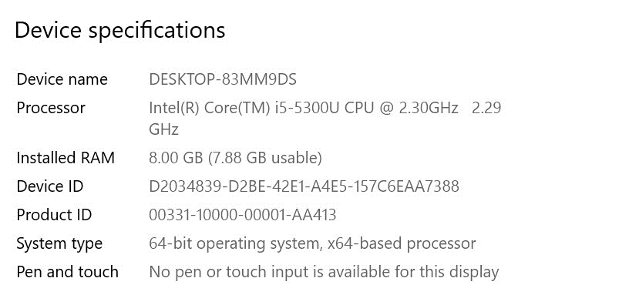
Figure 2:Device Specification

3.2 Software(s), simulation tool(s) used.
Software and tools are used to develop this application are following:
- Operating System Windows 10
- HTML
- CSS
- Bootstrap
- JavaScript
- Browser
- Flask (Python framework for backend)
- Python Interpreter
- MySQL (XAMPP)
- PyCharm (for writing code)
- Roboflow (data annotation, data Preprocessing and augmentation)
- YOLOv8 (for model training and validation)

3.2.1 Operating System Windows 10
An operating system (OS) is the program that manages all other application programs on a computer after it is initially loaded into the computer by a boot program. Application programs use the operating system by making requests for services through a defined application program interface. In addition, users can directly interact with the operating system through a user interface such as a command line or a graphical user interface.

3.2.2 MySQL (XAMPP)
MySQL, integrated within the XAMPP surroundings, played a crucial role in storing and managing the project's data. As a relational database management system, MySQL provided a robust and efficient solution for structuring, organizing, and retrieving data. XAMPP, acting as a local server stack, facilitated the seamless integration of MySQL, enabling effective communication between the database and the web application.

3.2.3 Python Interpreter
The Python interpreter is a crucial component of the Python programming language, serving as the execution environment for Python scripts and programs. It reads and interprets the human-readable Python code, converting it into machine-executable instructions. The interpreter allows developers to interactively test and run code snippets, making it ideal for rapid prototyping and debugging. Python's dynamic typing and automatic memory management are facilitated by the interpreter, which dynamically allocates and deallocates memory as needed. This interpreter-driven approach contributes to Python's reputation for being user-friendly and accessible to developers of varying skill levels.

3.2.4 PyCharm (for writing code)
PyCharm emerged as an indispensable tool in the development journey of the "Web Based Real-Time Fugitive Criminal Detection System Using Deep Learning." Serving as the primary integrated development environment (IDE), PyCharm provided an intuitive and feature-rich environment for coding and project management. Its robust code editor, intelligent code completion, and debugging capabilities significantly expedited the coding process and ensured code quality. PyCharm's seamless integration with version control systems and collaborative tools streamlined teamwork and code management. This IDE played a pivotal role in maintaining code consistency, enhancing productivity, and facilitating a smooth development experience throughout the project's lifecycle.

3.2.5 Roboflow (data annotation, data Preprocessing and augmentation)
Roboflow provides robust tools for data annotation, preprocessing, and augmentation. With its comprehensive suite of features, Roboflow enables us to efficiently label and annotate our dataset, ensuring the accuracy and quality of training data for deep learning models. Additionally, its data preprocessing capabilities facilitated seamless integration of diverse data sources, optimizing input for training. The platform's augmentation techniques enriched our dataset by generating variations of existing images, enhancing model generalization.

3.2.6 Browser
A web browser is a software application for accessing information on the World Wide Web. When a user requests a web page from a particular website, the web browser retrieves the necessary content from the web server and then displays the page on the user's device. We use different browsers when developing projects, especially the Chrome browser.

3.2.7 HTML
Hypertext Markup Language (HTML) is the standard markup language for documents designed to be displayed in a web browser. HTML literally describes the structure of a web page and the instructions included for the document's appearance. HTML elements are the building blocks of HTML pages. With HTML construction, images, and other objects such as interactive forms can be embedded into the rendered page.

3.2.8 CSS
Cascading Style Sheets (CSS) is a style sheet language used to describe the presentation of a document written in a markup language such as HTML. CSS is a core technology of the World Wide Web, along with HTML and JavaScript. CSS is designed to enable presentation and separation of content, including layout, colors, and fonts.

3.2.9 Bootstrap
Bootstrap is a free and open-source CSS framework for responsive, mobile-first web development. It includes CSS- and (optionally) JavaScript-based design templates for typography, forms, buttons, navigation, and other interface components. Simply put, Bootstrap is a wide array of tools that rely on reusable code, so you don't have to develop the building blocks of a website from scratch. There are different versions of Bootstrap, but we use Bootstrap version 5 while building our project.

3.2.10 JavaScript
JavaScript is a versatile and widely used programming language that operates within web browsers to enhance the interactivity and dynamic nature of websites and web applications. As a client-side scripting language, it enables developers to create responsive user interfaces, handle user interactions, and manipulate web page content in real-time. JavaScript plays a crucial role in enabling features such as form validation, animations, and asynchronous operations, ensuring a seamless and engaging user experience. Its flexibility and compatibility across different platforms make it an essential tool for building modern web applications that provide functionality beyond static content presentation.

3.2.11 Flask(Python framework for backend)
Flask, a powerful micro web framework, played a pivotal role as the backend technology in the development of our project. Built on Python, Flask provided a lightweight yet flexible foundation for handling server-side logic, routing, and data processing. Its modular design allowed for easy integration of various components, enabling efficient data retrieval, manipulation, and communication between the frontend and the database. Flask's simplicity and extensibility made it an ideal choice for managing user authentication, data storage, and dynamic content generation, contributing to the seamless operation and functionality of the application.

3.2.12 YOLOv8 (for model training and validation)
YOLOv8, an acronym for "You Only Look Once version 8," stands as a cutting-edge deep learning framework that played a crucial role in the model training and validation of our project. Leveraging state-of-the-art object detection capabilities, YOLOv8 enabled the identification and localization of objects within images or video frames with exceptional speed and accuracy. Its architecture incorporates advanced convolutional neural networks and techniques like anchor boxes and feature pyramid networks, making it particularly adept at detecting objects of varying sizes and orientations. Through YOLOv8, our system was empowered to perform real-time fugitive criminal detection with high precision and efficiency, contributing significantly to the success and effectiveness of our web-based application.

3.3 Summary
In this chapter we discussed the tools and technologies in the development of our project.
We harnessed a diverse array of tools and technologies to create a robust and efficient real-time fugitive criminal Identification system. Our front-end interface was crafted using HTML, CSS, and Bootstrap, ensuring an engaging and user-friendly design. The integration of JavaScript further enriched the user experience, enabling dynamic and interactive features. On the backend, we employed Flask, a Python web framework, to manage server-side logic and seamlessly handle user requests. Our data was efficiently stored and retrieved using MySQL, a powerful relational database management system.
For the core of our system's intelligence, YOLOv8, an advanced deep learning framework, played a pivotal role. YOLOv8 empowered our model with remarkable object detection capabilities, enabling real-time identification and localization of fugitive criminals within images and video streams. To enhance the accuracy and effectiveness of our model, we utilized Roboflow for data annotation, preprocessing, and augmentation, ensuring robust training and validation datasets.
The amalgamation of these tools and technologies culminated in a comprehensive solution that merges user-friendly design with state-of-the-art deep learning techniques. This project showcases the seamless integration of software and hardware elements to create a powerful, real-time criminal detection system accessible through a user-friendly web interface.

Chapter 4

METHODOLOGIES
Software development methodology is a structured process used in software development, providing a framework to guide the design and creation of software. This methodology incorporates principles, rules, and systematic procedures for various activities within the software development lifecycle. In addition to typical software development phases like planning, analysis, design, programming, testing, and implementation, our project involves distinct data-centric tasks. These include data collection, data annotation, and model training, crucial for the successful implementation of deep learning techniques. Svoboda's (1990) framework identifies four essential components of a methodology:
- Conceptual model of the constructs necessary for the problem
- A set of procedures that prescribes the direction and sequence to proceed.
- A series of guidelines indicating things to avoid.
- A set of evaluation criteria to assess product quality.
Our project's unique aspect lies in its integration of these methodologies with deep learning techniques. We harness deep learning models to analyze criminal data, making real-time fugitive identification possible. This necessitates a comprehensive approach, combining software development principles with data-focused strategies. As we delve into the methodology, we will document our processes, providing a clear description of how data collection, annotation, model training, and software design intertwine to achieve the project's objectives. This structured approach ensures transparency and efficiency in our pursuit of our project.

4.1 Analysis procedures
The model that is mainly being followed is the waterfall model, which states that the steps are arranged in a linear sequence. First, the possibilities are studied. Once that part goes through a requirements analysis and project planning begins. If the system is an existing one and a new module needs to be changed and added, the analysis of the existing system can be used as a base model.
Data Collection and Annotation: The foundation of our project involved collecting a comprehensive dataset of criminal profiles, which forms the backbone of our deep learning models. This dataset included criminal records, photographs, and relevant information. To ensure data quality, an extensive annotation process was carried out to label criminal attributes accurately. Human annotators were trained to categorize and tag the data, maintaining consistency and reliability. The annotated dataset served as the training ground for our deep learning models, empowering us to recognize and identify fugitive criminals with high accuracy.
After the requirement analysis is completed, the design begins and after the design is completed, the coding begins. After programming is complete, testing is done. In this model, the sequence of activities performed in a software development project is:-
- Requirements analysis
- Project planning
- System design
- Detailed design
- Coding
- Unit testing
- System integration and testing
The linear sequence of these activities is important here. The output of one stage is the input of another stage. The output of each stage should be proportional to the overall system requirement. Spiral models also have some advantages such as the evaluation of the work of the people involved in the project after each stage is completed.
The waterfall model was chosen because all the requirements were known in advance, and our software development aimed at computerization/automation of the already existing manual working system.

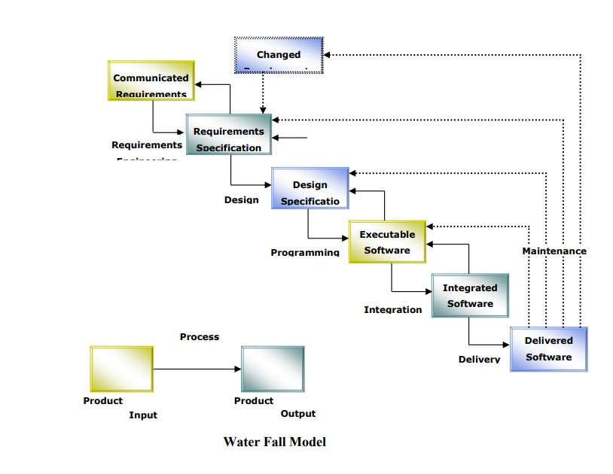
Figure 3:Waterfall Model

4.1.1 SOFTWARE REQUIREMENT SPECIFICATION
SRS provides the prerequisites for in-depth research of existing systems and the construction of an innovative identification system.
Purpose: The main purpose of preparing this document is to provide a general insight into the current system or situation analysis and requirements and to determine the operating characteristics of the system.
Scope: This document plays an important role in the development of life cycle (SDLC), and it describes the complete system requirement. This is for use.
Developers and will be core during the testing phase. Any future changes to the requirements will have to go through a formal change approval process.

4.1.2 DEVELOPERS RESPONSIBILITIES OVERVIEW:
Developer responsibilities are:
- Collecting, interpreting, modeling, and validating datasets
- Developing an SSRS compliant system and meeting all system requirements.
- Demonstrating the system after successful acceptance testing and installing the system at the client location.
- Submission of the required user manual describing the system interface and system documentation to work on it.
- Conduct any user training required to use the system.
- Maintaining the system for a period of one year after installation.

4.1.3 Feasibility Report
Preliminary investigations assess the feasibility of the project, and the likelihood that the system will be useful to the organization. The main objective of the feasibility study is to check the technical, operational, and economic feasibility of adding new modules and debugging the old operating system. All systems are possible if they have unlimited resources and unlimited time. Some aspects of the feasibility study part of the preliminary investigation are:
- Technical Feasibility
- Operation Feasibility
- Economic feasibility

4.1.4 Technical Feasibility
Technical issues that are typically raised during the feasibility phase of the investigation include the following:
- Does the necessary technology exist to carry out the proposed work?
- Does the proposed equipment have the technical capability to hold the data required to use the new system?
- Will the proposed system provide adequate response to queries regardless of the number or location of users?
- Can it be upgraded as the system evolves?
- Are there technical guarantees for accuracy, reliability, ease of access, and data security?
Previously, there was no system in place to address the system requirements for implementing secure infrastructure. The current system is technically viable. It is a web-based user interface for audit workflow in NIC-CSD, providing easy access to users. The purpose of the database is to create, establish and maintain workflows between different entities to facilitate all relevant users in their various capacities or roles. Users will be granted permissions based on specific roles. Therefore, it provides a technical guarantee of accuracy, reliability, and security. The software and hardware requirements for the development of this project are not extensive and are already available in-house at NIC or are available as open source. Project work is carried out with existing equipment and existing software technology. Regardless of the number of users using the system, the necessary bandwidth is available to provide fast feedback to users.

4.2 Design of the investigation
UI Design reviews the site analysis document and creates different pages for the complete system starting with the home page. At this stage, we begin to imagine what our website will look like. This is the best time to propose changes to the system as this phase can accommodate any changes needed. Final is now converted to a platform-specific HTML skin based on the recommended e-commerce platform. This step is very important because the delivered HTML will dictate how the site works. By ensuring that HTML conforms to web standards, we speed up the process and avoid costly mistakes.
Project design is the initial phase of the project where key project characteristics, structure, success criteria, and key deliverables are planned. The point is to develop one or more designs that can be used to achieve desired project goals. Stakeholders can then choose the best design to use for the actual completion of the project. The project design phase can produce a variety of outputs, including diagrams, flowcharts, site trees, HTML screen designs, prototypes, and graphical simulations. Below are some designs that describe the workflow and functionality of our system. By incorporating this design, it is now easier to understand the system and its function. In these designs, we have defined the system more simply. These designs include activity diagrams, system cases, and class diagrams.

4.2.1 Model Training:
The heart of our project lies in the training of deep learning models to identify fugitive criminals in real-time. Here are the key steps involved in model training:
- Data Collection and Annotation: As mentioned in the Analysis Procedures section, a comprehensive dataset of criminal profiles was collected. To make our models effective, this data underwent meticulous annotation, ensuring each attribute was accurately labeled. The annotation process was carried out by annotators, maintaining data quality and privacy standards.
- Data Preprocessing: Before training, the data underwent preprocessing, which included data cleaning, normalization, and augmentation to ensure it's suitable for training.
- Model Selection: For the core of our models, we turned to YOLOv8, a state-of-the-art deep learning architecture designed specifically for real-time object detection and recognition tasks. YOLOv8, short for "You Only Look Once," is renowned for its speed and accuracy in identifying objects in images and videos.
- Training: The annotated dataset served as the foundation for YOLOv8 model training. The models were trained using YOLO's advanced deep learning framework, iteratively improving their ability to recognize criminal attributes.
- Validation and Testing: To ensure the models' accuracy and generalization, rigorous validation and testing were performed. A portion of the dataset was reserved for testing, and performance metrics were evaluated.
- Deployment: The trained YOLOv8 models were integrated into our web-based system for real-time criminal identification.
This comprehensive approach to model training, with the utilization of YOLOv8, ensures that our system can reliably and efficiently identify fugitive criminals, making a valuable contribution to law enforcement efforts.

4.2.2 Use Case Diagram
Use Case diagrams are used to analyze the high-level requirements of a system. When analyzing system requirements, functions are captured in use cases. Case diagrams describe system events and their flow. But use case diagrams never explain how they are implemented. A case diagram can be viewed as a black box where only the input, output, and function of the black box are known. These diagrams are used at a very high level of design. This high-level design is iteratively refined to obtain a complete and functional picture of the system. So, we can say that use cases are nothing, but functions of a system written in a systematic way. Now another thing that is related to use cases are actors. Actors can be defined as objects that interact with the system. Actors can be human users, some internal applications or perhaps some external applications. So, in short when we are planning to create a use case diagram, we should have the following items identified in the use case diagram:
- Each functionality represented as use cases.
- Actors
- Relationships among the use cases and actors

4.2.2.1 Use Case Terminology
A use case describes a sequence of actions that deliver measurable value to an actor.
- Actor: An actor is a person, organization, or external system that plays a role in one or more interactions with your system.
- Associations: An association exists whenever an actor engages in an interaction described in a use case. Associations are created as lines connecting use cases and actors to each other.
- System Boundary: A rectangle around the use cases, called the system boundary, to indicate the scope of the system.
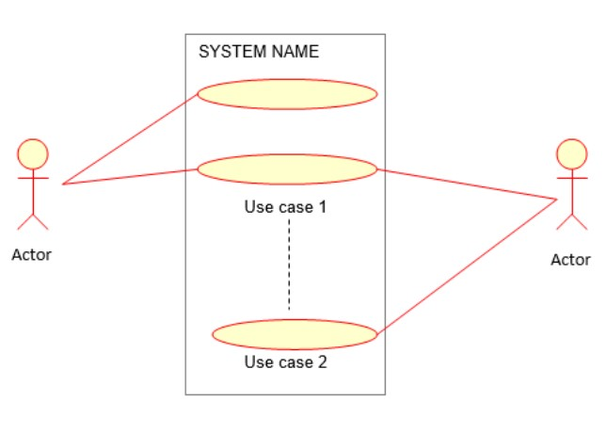
Figure 4:Use Case Terminology

4.2.2.2 Use case of Head Admin (IG)
Admin site login is required when used by the Head Admin. Head admin must enter the correct login and password. After entering the correct details, the Head Admin will click on the Login button. Then the head admin can login, register security room in-charge, View and delete security room in-charge, register city officer, View, and delete city officer, Reset own password.
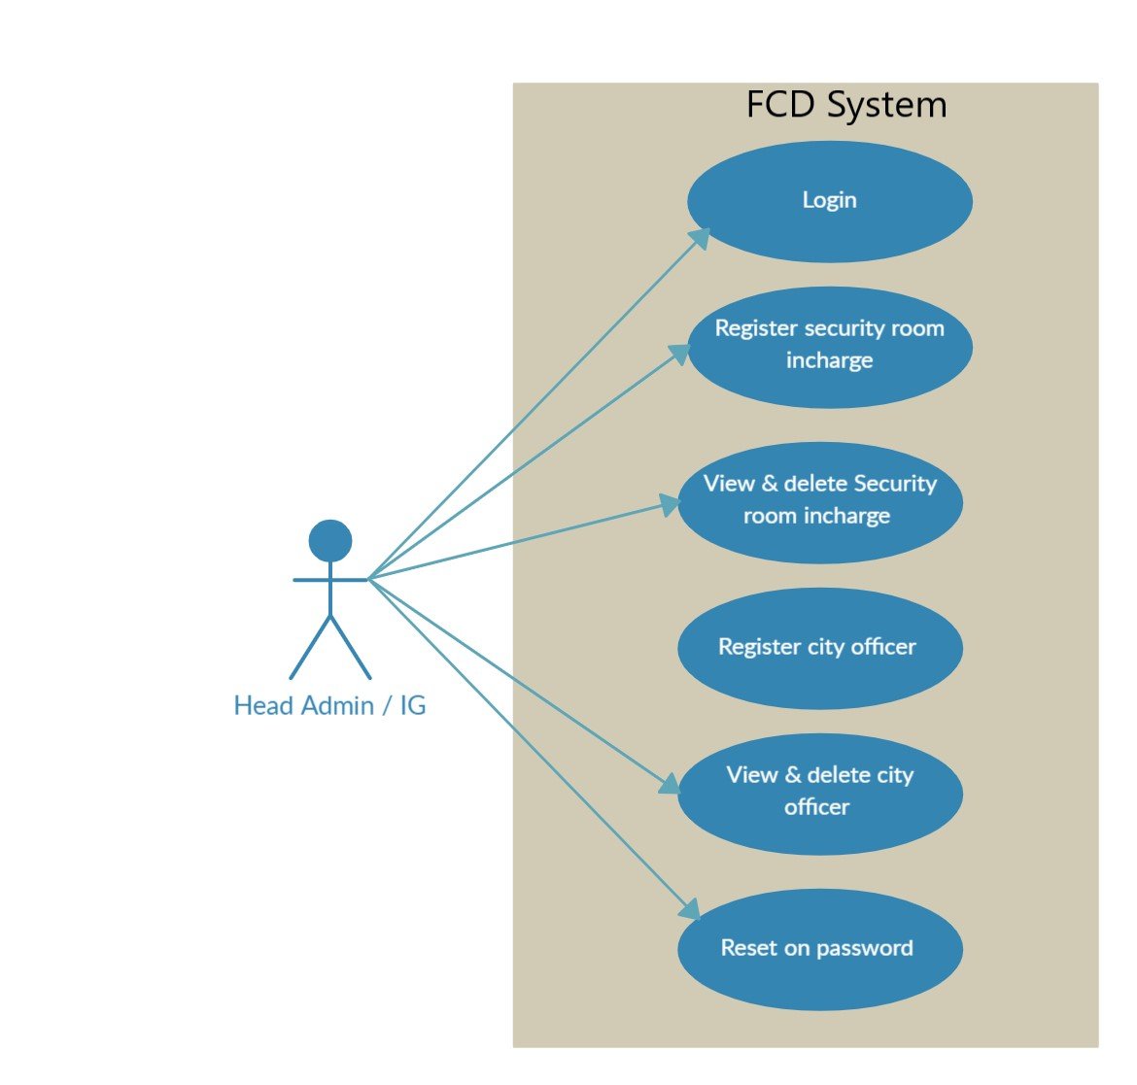
Figure 5:Use Case of Head-Admin

When the Head Admin (IG) types after logging in to the admin page, he types the information about him, and then he sees the functionality of the admin as shown in Table 1.

Table 1:Use Case of Head-Admin
Use case ID | 0.1
Use Case Name: | Login
Actor | Head-Admin / IG
Use case Description | How Head-Admin / IG can login?
Pre-conditions: | Head-Admin must enter correct username and password. After entering correct details, the head-admin will click the login button.
Post conditions: | If head-admin does not enter a correct username or password, they will not go to admin dashboard.
Basic path: | Enter login username and password for login. Click the login button. System verifies the username and password. If username and password, then he can login into our website. For a verified admin the entered details must be correct.
Constraints: | If username or password is wrong, then head-admin will be on same page. If the head-admin not verified through username, then also error message shows to him.
Non-Functional requirement: | Better performance. Security. Availability. Short response time.

4.2.2.3 Use case of Admin (City Officer)
Admin site login is required in case of admin usage. Admin must enter a valid login and password. After entering the correct details, the administrator will click on the login button. Then the admin login, register security room in-charge, View and delete security room in-charge, Reset own password.
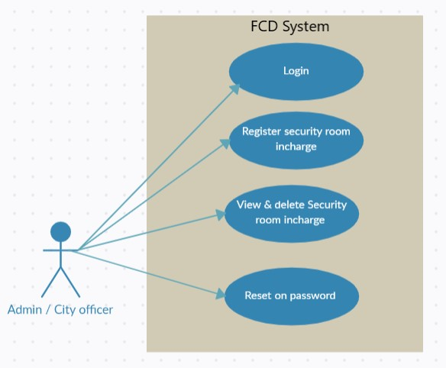
Figure 6:Use Case of Admin

When the admin/city officer logs in to the admin page write information about them after their categories then he saw the functionality of admin as shown in the Table 2.

Table 2:Use Case of Admin
Use case ID | 0.2
Use Case Name: | Login
Actor | Admin / City-officer
Use case Description | How Admin / City-officer can login?
Pre-conditions: | Admin must enter correct username and password. After entering correct details, the admin will click the login button.
Post conditions: | If admin does not enter a correct username or password, they will not go to admin dashboard.
Basic path: | Enter login username and password for login. Click the login button. System verifies the username and password. If username and password, then he can login into our website. For a verified admin the entered details must be correct.
Constraints: | If username or password is wrong, then admin will be on same page. If admin not verified through username, then also error message shows to him.
Non-Functional requirement: | Better performance. Security. Availability. Short response time.

4.2.2.4 Use case of User (Security room incharge)
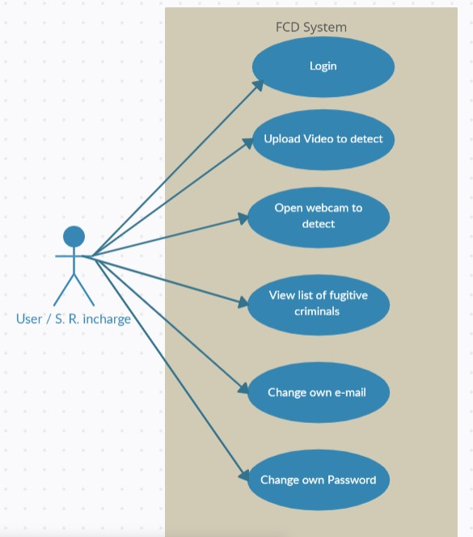
Use case of user, user must login the user’s home. Enter username and password and click the submit button. Then the user can login, upload video to do detection, open webcam to detect, see list of fugitive criminals, change their own password, change their own e-mail.
Figure 7:Use Case of User

After the login user page when the user/security-room-Incharge types his information about himself he sees the user attributes as shown in Table 3.

Table 3:Use Case of User
Use Case ID | 0.3
Use Case Name: | Security room incharge login
Actor | User / security room incharge
Use Case Description | How can the user/incharge see our website homepage?
Pre-conditions: | Login is compulsory for the home page.
Post conditions: | User/incharge can leave the home page after visit.
Basic path: | Enter login username and password for login. Click the login button. System verifies the username and password. If username and password, then he can login into our website. For a verified user/incharge the entered details must be correct.
Constraints: | User/incharge can visit my website at any time.
Non-Functional requirement: | Availability. Short response time.

4.2.3 Activity Diagram
An activity diagram is another important diagram in UML for describing the dynamic aspects of a system. An activity diagram is basically a flowchart that represents one activity from another. Activity can be defined as the operation of a system. Control flow is drawn from one operation to another. This flow can be sequential, branched, or synchronous. Activity diagrams deal with all types of flow control using various elements such as forks, joins, etc.

4.2.3.1 Purpose of Activity diagram
Activity diagrams have the same basic purpose as the other four diagrams. It captures the dynamic behavior of the system. The other four diagrams are used to show the message flow from one object to another, but the activity diagram is used to show the message flow from one activity to another. The purpose of an activity diagram can be described as follows.
- Draw the activity flow of the system.
- Explain the sequence from one activity to another.
- Explain parallel, branched, and parallel flow systems.

4.2.3.2 Initial state or start point.
A small, filled circle followed by an arrow represents the initial action state or starting point for any activity diagram. To outline an activity using a swim lane, make sure the starting point is placed at the top of the first column. This symbol for the initial state.

Figure 8:Initial state or start point.

4.2.3.3 Activity or action state
An action state represents a non-interruptive process of objects. You can create action states in Smart Draw using rectangles with rounded corners. This symbol is used to represent activity.

Figure 9:Activity or Action state

Action flows, also called edges and paths, illustrate transitions from one process state to another. They are usually drawn along an arrowed line.
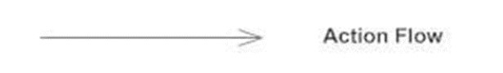
Figure 10:Action Flow

Object flow refers to the creation and modification of objects by activities. An arrow from an object to an object means that the action creates or affects the object. The flow of objects from an object to a process an arrow indicates the state of that process.
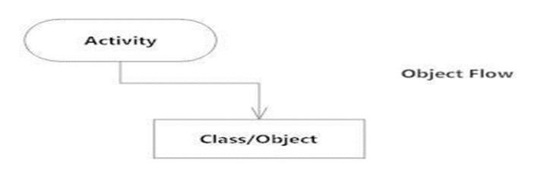
Figure 11:Object Flow

4.2.3.4 Decision and Branching
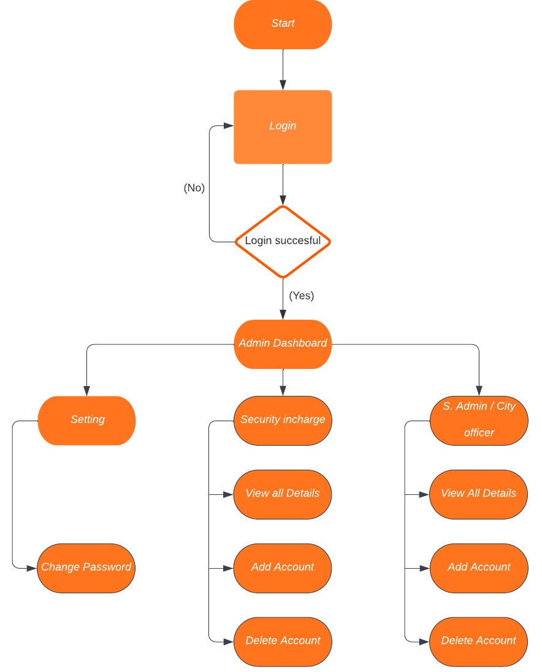
A diamond represents a decision with alternative paths. When an activity requires a decision before moving on to the next activity, add a diamond between the two activities. You can also label one of the paths "and" as shown. Figure 12 shows the function of Head Admin/IG. How Head Admin/IG can login and perform various operations.
Figure 12:Decision and Branching

Figure 13 shows admin/city-officer working. How he can login and perform operations.
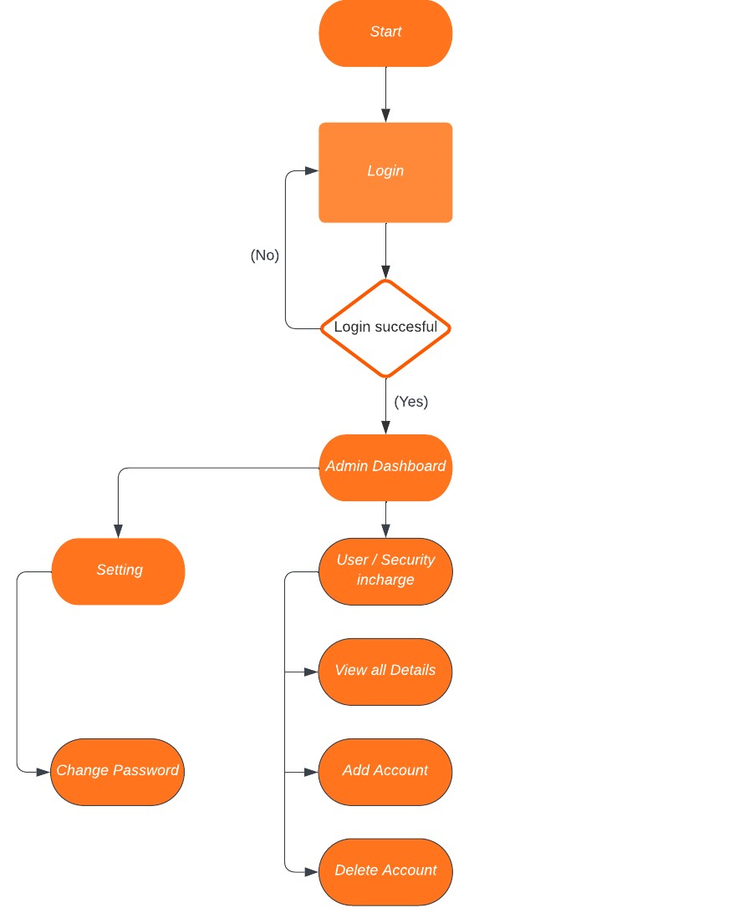
Figure 13:Decision and Branching

Figure 14 shows the working of user/security-room-incharge. How user/security-room-incharge can login and perform different operations.
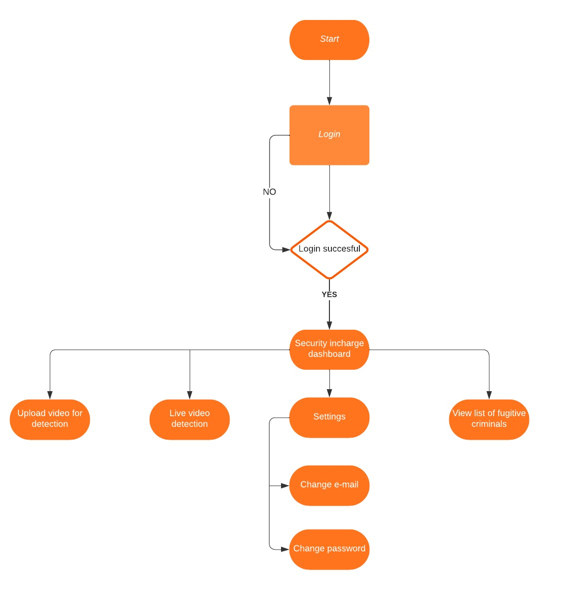
Figure 14:Decision and Branching

4.2.4 Sequence Diagram
A sequence diagram simply shows the interactions between objects in a sequential order such as the order in which these interactions occur. We can also use the terms event diagrams or event scenarios to refer to sequence diagrams. Sequence diagrams show how and in what order the objects in the system work. UML has introduced significant improvements in the capabilities of sequence diagrams. Most of these reforms are based on the idea of ​​fragmentation. The object calling methods use the messages themselves and add new activation boxes on top of each other to indicate further levels of processing. If an object is destroyed, an X is drawn below the lifeline, and the dashed line stops forming below it. It must be the result of a message, either from the object itself or from someone else.
A message sent from outside the diagram can be represented by a filled circle or by a message coming from the border of the layout diagram. Admin and User Configuration Diagram as shown in Figure 15.

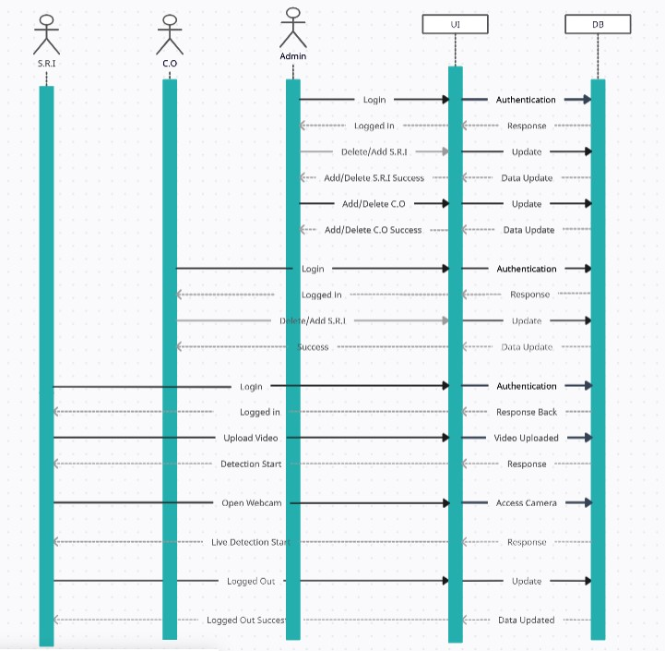
Figure 15:Sequence Diagram

4.2.4.1 Entity Relationship Diagram
An entity relationship diagram shows how entities such as people, objects, or concepts are related to each other in a particular system. ERD can help users visualize abstract elements to understand and discuss the relationship between different concepts. ER (crowfoot) diagram as shown in Figure 16.
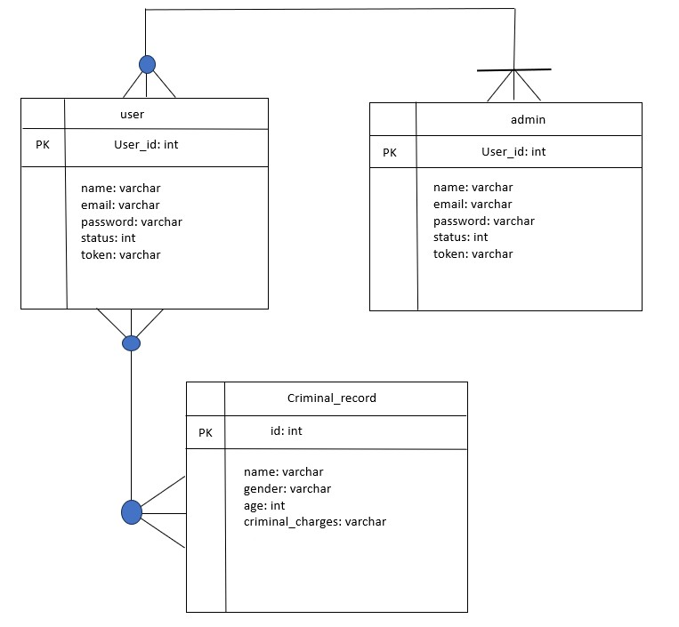
Figure 16:Entity Relationship Diagram

4.2.5 Incremental Model
In the incremental model, the entire requirement is divided into different constructs. There are multiple developmental cycles, making the life cycle a multi-cascade cycle. In this model, cycles are broken down into smaller, more easily managed parts, with each module going through requirements, design, and implementation and testing phases. It combines elements of linear and parallel process flow. Each linear sequence produces a software deliverable increment. The first addition is often a basic product with many additional features. Users use it and evaluate it with further modifications to better meet the needs.

4.2.5.1 Principle of Incremental Model
- These principles are defined by the stages of incremental method engineering and the mechanisms implemented in each stage.
- These measures are concerned with gathering experience and improving procedures for the current situation.
- These steps lack a method and with the priority method they form the iterative loop of the incremental method.
- Throughout these stages we apply three mechanisms that seek to improve practices. These mechanisms are based on analyzing the gap between intended and actual use of modeling techniques, studying the role techniques play in modeling object systems, and understanding how they help solve the problem.
- Create a partial implementation of the total system.
- Then gradually add increasing functionality.
- The enhancement model prioritizes system requirements and then implements them into groups.
- Each subsequent release of the system adds functionality to the previous release, until all designed functionality is implemented.
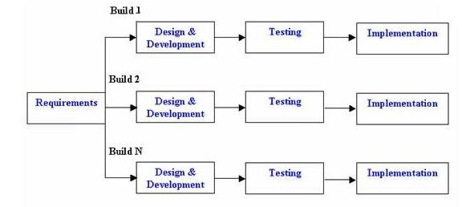
Figure 17:Incremental Model

4.2.5.2 Advantages
- Generates working software quickly and early during the software life cycle.
- This model is more flexible and less costly to change scope and requirements.
- It is easier to test and debug during a smaller iteration.
- In this model the customer can respond to each built.
- Lowers initial delivery cost.
- Easier to manage risk because risky pieces are identified and handled during its iteration. The incremental model prioritizes requirements of the system and then implements them in groups.
- Each subsequent release of the system adds functionality to the previous release, until all designed functionality is implemented.
- Prepare for high risk or large tasks first.
- Each release delivers an operational product.
- Initial product delivery is fast.

4.3 Implementation procedure
System implementation is a very important step for any website. It is the process that obtains the lowest level system element in the system hierarchy. System implementation uses the framework created during architectural design and the results of system analysis to build system elements that meet stakeholder requirements developed in early life cycle phases.

4.3.1 Details about Hardware
There are no formal minimum hardware requirements for web app hosting. Hardware specifications will change under the influence of various factors that must be considered to determine the best hardware specifications for a web and database server. Table 4 shows the approximate hardware specifications for installing the project.

Table 4:Details about Hardware
Item | Web Server Minimum | Web Server &Database Server
Processor | 2.30 GHz CPU | 2*2.30 GHz CPU
RAM | 3.75 GB RAM | 5.5 GB RAM
HDD | 3 GB Free Space | 3 GB Free Space

Above we discuss how estimates can be made. Now the following are the general hardware requirements that we use to develop software. We require the following hardware and specifications to implement and deploy this website.
- Processor: intel core i5-5300U
- RAM: 8 GB RAM

4.3.2 Details about software
Below is the detail of our software:

4.3.2.1 Deep Learning Model:
The core functionality of our system relies on YOLOv8, a state-of-the-art deep learning framework designed for real-time object detection tasks. YOLOv8 was utilized to train models for identifying fugitive criminals in real-time.

4.3.2.2 Backend Development:
To establish the system's backend logic and handle model integration, we opted for Flask, a micro web framework for Python. Flask allowed us to create communication between the frontend and the deep learning models.

4.3.2.3 Database Integration:
MySQL, a robust relational database management system, was integrated into our system to manage admin and user data. The database stores essential information such as admin and user profiles, fugitive criminal records.

4.3.2.4 Frontend Development:
The user interface of our web-based system was developed using a combination of web technologies:
HTML: To create the structure and content of web pages.
CSS: To style user interface, ensuring attractive design.
Bootstrap: Framework that streamlined the design process, resulting in a responsive and visually appealing interface.
JavaScript: For adding interactivity and enhancing user experience.

4.4 Verification of functionalities
It is used to check whether the product conforms to the specifications we intended for it as well as charted out for it in our development documentation.

4.4.1 Head-Admin/IG Functionalities
- Head-Admin can add admins/city-officers.
- Head-Admin can view all admins/city-officers.
- Head-Admin can delete admins/city-officers.
- Head-Admin can add users/security-room-incharge.
- Head-Admin can view all users/security-room-incharge.
- Head-Admin can delete users/security-room-incharge.
- Head-Admin can change their own password.

4.4.2 Admin/city-officers Functionalities
- Admin can add users/security-room-incharge.
- Admin can view all users/security-room-incharge.
- Admin can delete users/security-room-incharge.
- Admins can change their own password.

4.4.3 User/Security-room-incharge Functionalities
- Users can upload video to do detection.
- Users can open webcam to detect fugitives.
- Users can view a list of fugitive criminals.
- Users can change their own Password and Email.

4.4.4 Nonfunctional Requirement
These requirements define requirements in terms of performance, design constraints, compliance with standards.

4.4.4.1 Availability
Availability is the ratio of the time a system or component is required to operate and is expected to operate.
- Application should be responsive and available any time.
- Application must be worked on time efficiently.

4.4.4.2 Reliability
- The system should be reliable.
- System should not produce an incorrect output.

4.4.4.3 Maintainability
Making changes or upgrading the site won't be that difficult. With some programming knowledge, some features of the application can be changed in the new version.
- System should perform a successful action within a given time.

4.4.4.4 Performance
The product will be web-based and must be run from a web server. The product will take an initial load time depending on the strength of the Internet connection which also depends on the media from which the product is run. Performance will depend on the hardware components of the administrator/user.
The Performance of our system is in the sense that:
- The system should be fast.
- System should support the capability to use multi-user environment.
- System must perform well.

4.4.4.5 Portability
- Easy to access anywhere any time.

4.4.4.6 Consistency
- There should be consistency when the administrator is updating the information.

4.4.4.7 Database Requirement
In this section, the database requirements for this website are mentioned: We use phpMyAdmin for our database management system. In this phase of the project all processes are coded, and back-end database management tools are created.

4.4.4.8 Database Tables
change MySQL is the database name, having tables.

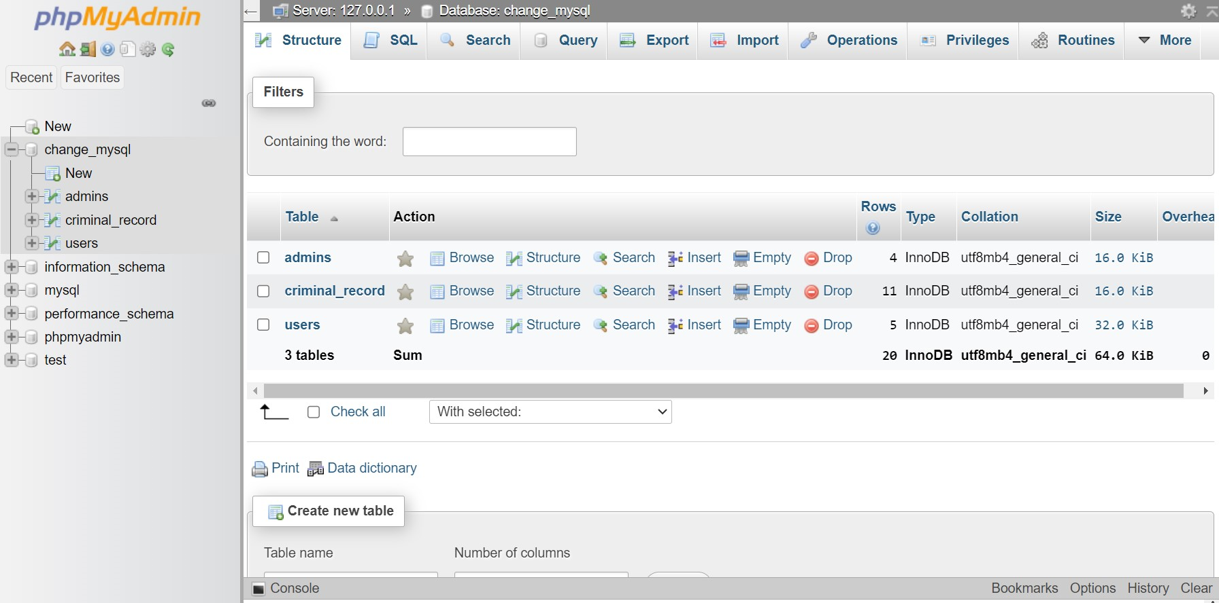
Figure 18:Database Table

4.5 Simulation / mathematical modeling
Modeling and simulation allow the designer to incorporate a large amount of implicit system detail into plans. Here's how it works.

4.5.1 Admin Login
Image Represent admin login. Figure 19 shows login page.
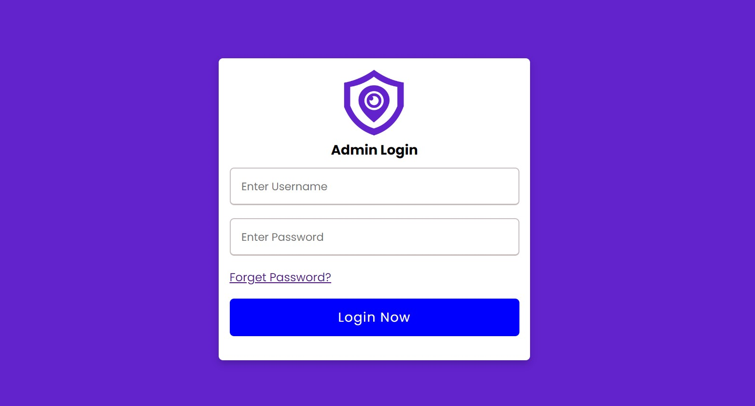
Figure 19:Admin Login

4.5.2 Head-Admin Dashboard
This Screenshot Represent the Demo presentation A Document Processing System from head-admin dashboard. Figure 20 shows the head-admin side page.

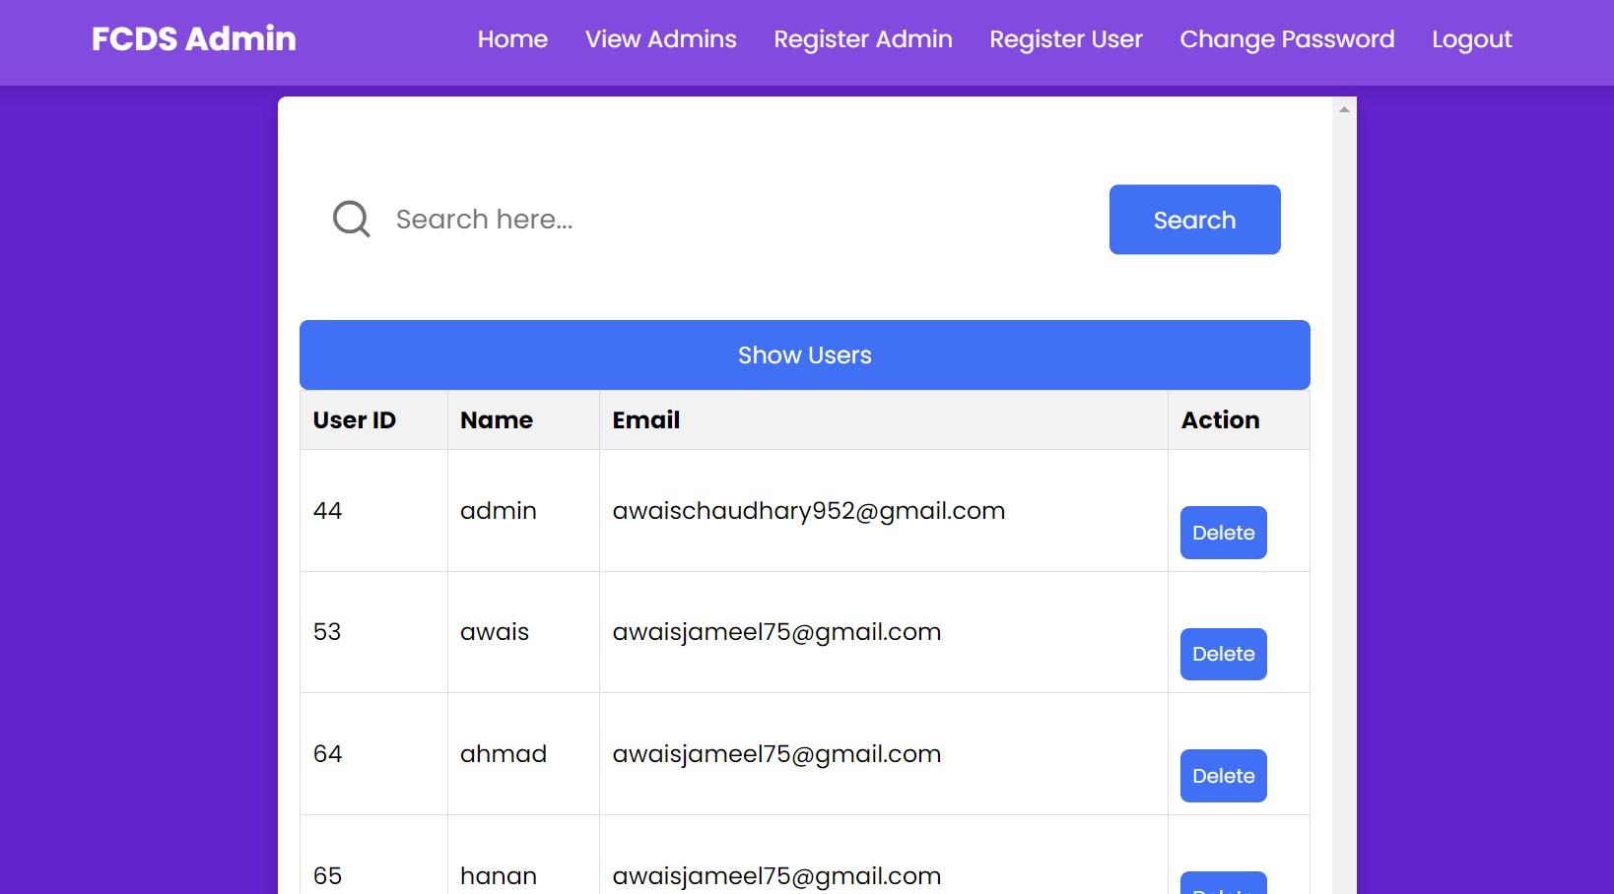
Figure 20:Head-Admin Dashboard

4.5.3 Register Admin
Figure 21 Represent the Demo presentation of Admin Registration.

Figure 21:Register Admin

4.5.4 View all Admins.
Figure 22 Represent the Demo presentation of admin page to view all Admins page.
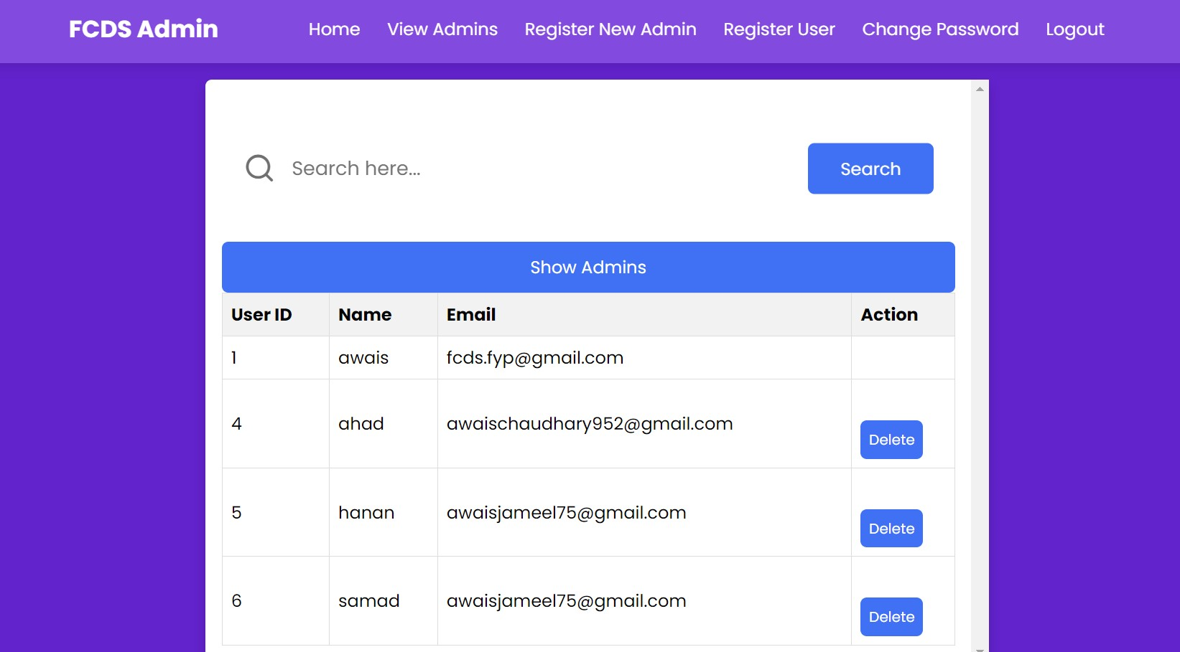
Figure 22:View all Admins

4.5.5 Admin Dashboard
This Screenshot Represent the Demo presentation A Document Processing System from admin dashboard. Figure 23 shows the admin side page.
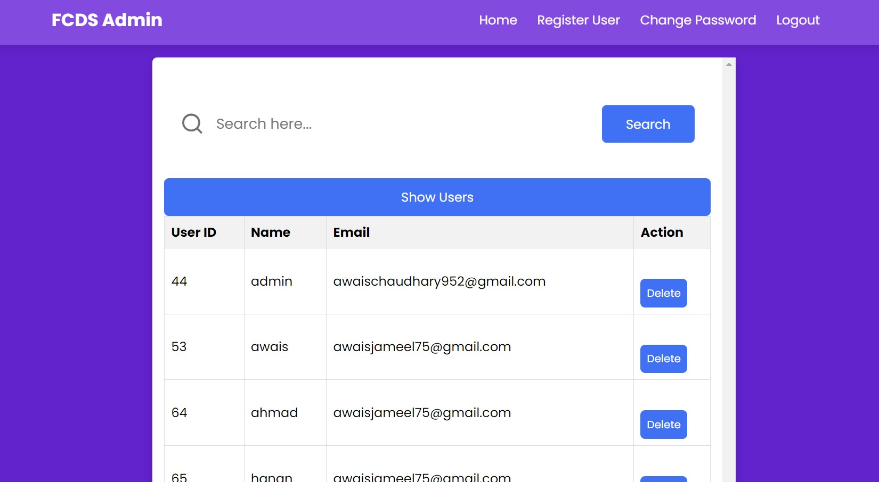
Figure 23:Admin Dashboard

4.5.6 Register User
Figure 24 Represent the Demo presentation of User Registration.

Figure 24:Register User

4.5.7 Admin Reset/Change Password
Figure 25 Represent the Demo presentation of Admin Reset/Change Password page.
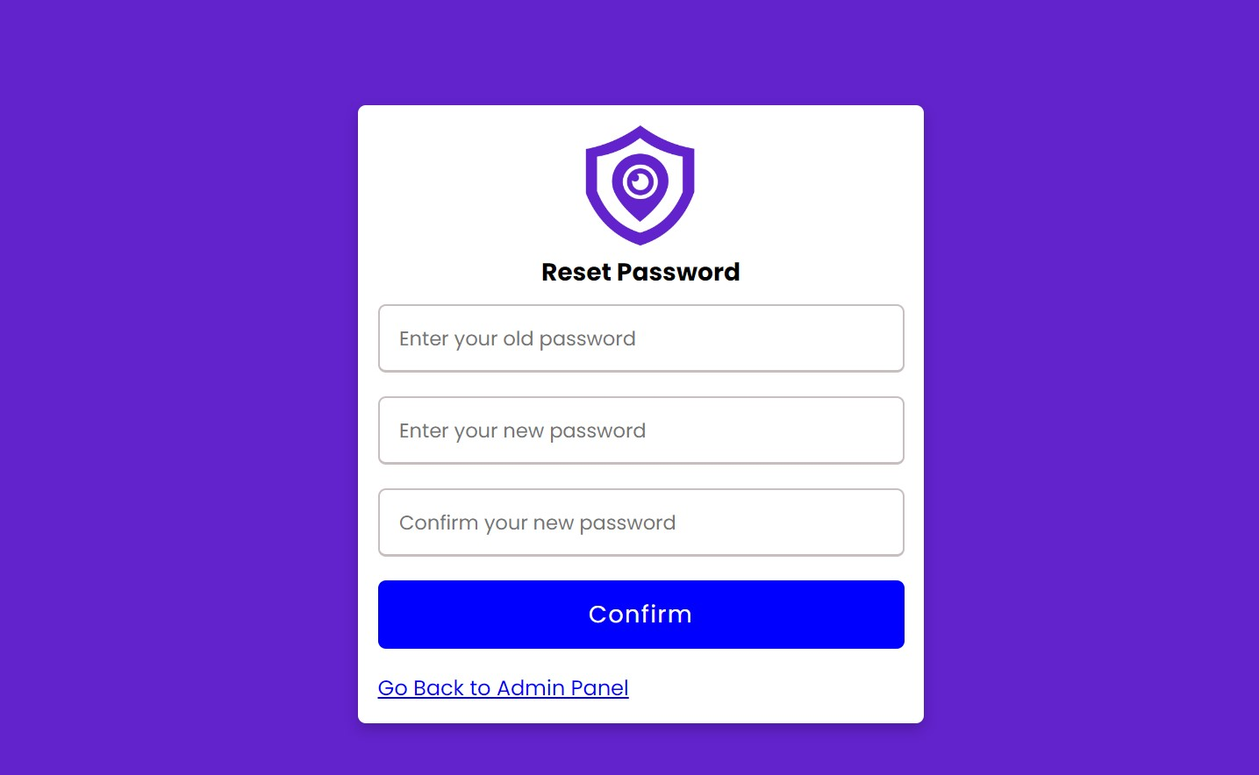
Figure 25:Admin Reset/Change Password

4.5.8 Admin Forget Password
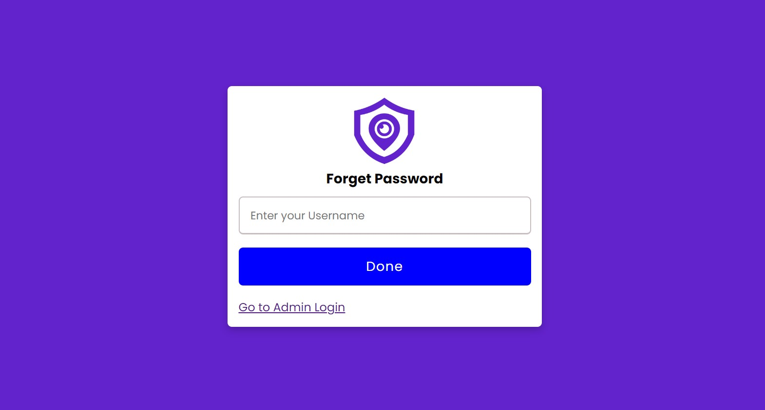
Figure 26 Represent the Demo presentation of Admin Forget password page.
Figure 26:Admin Forget Password

4.5.9 User Login
Figure 27 Represent the Demo presentation from user login. Figure 4.20 shows login page.
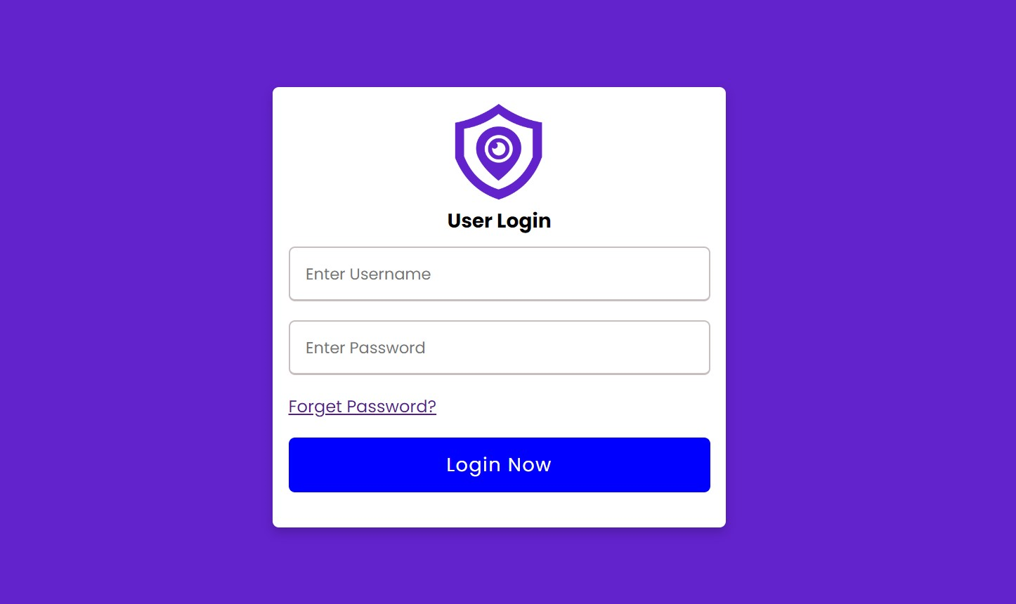
Figure 27:User Login

4.5.10 User Forget Password
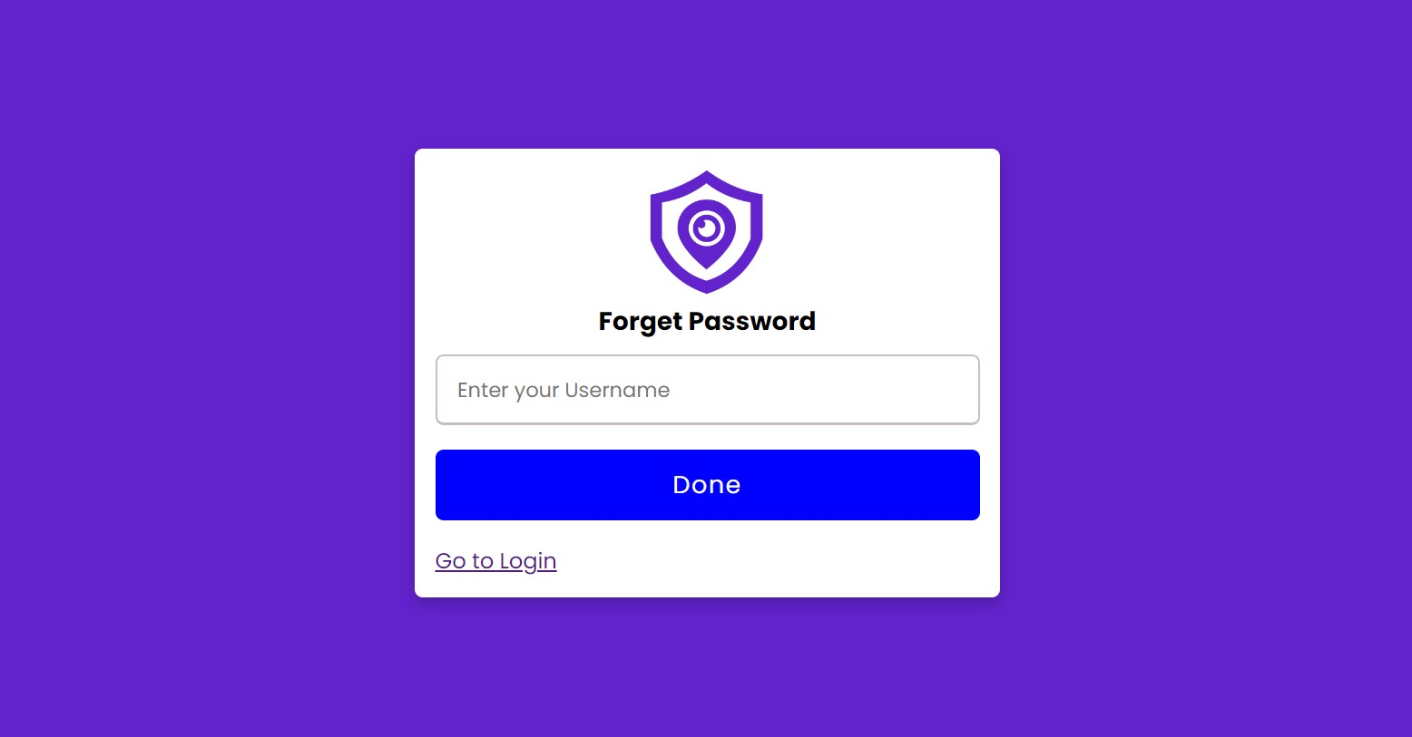
Figure 28 Represent the Demo presentation of User Forget password page.
Figure 28:User Forget Password

4.5.11 User Dashboard
Figure 29 Represent the Demo presentation of User Dashboard/Index page.
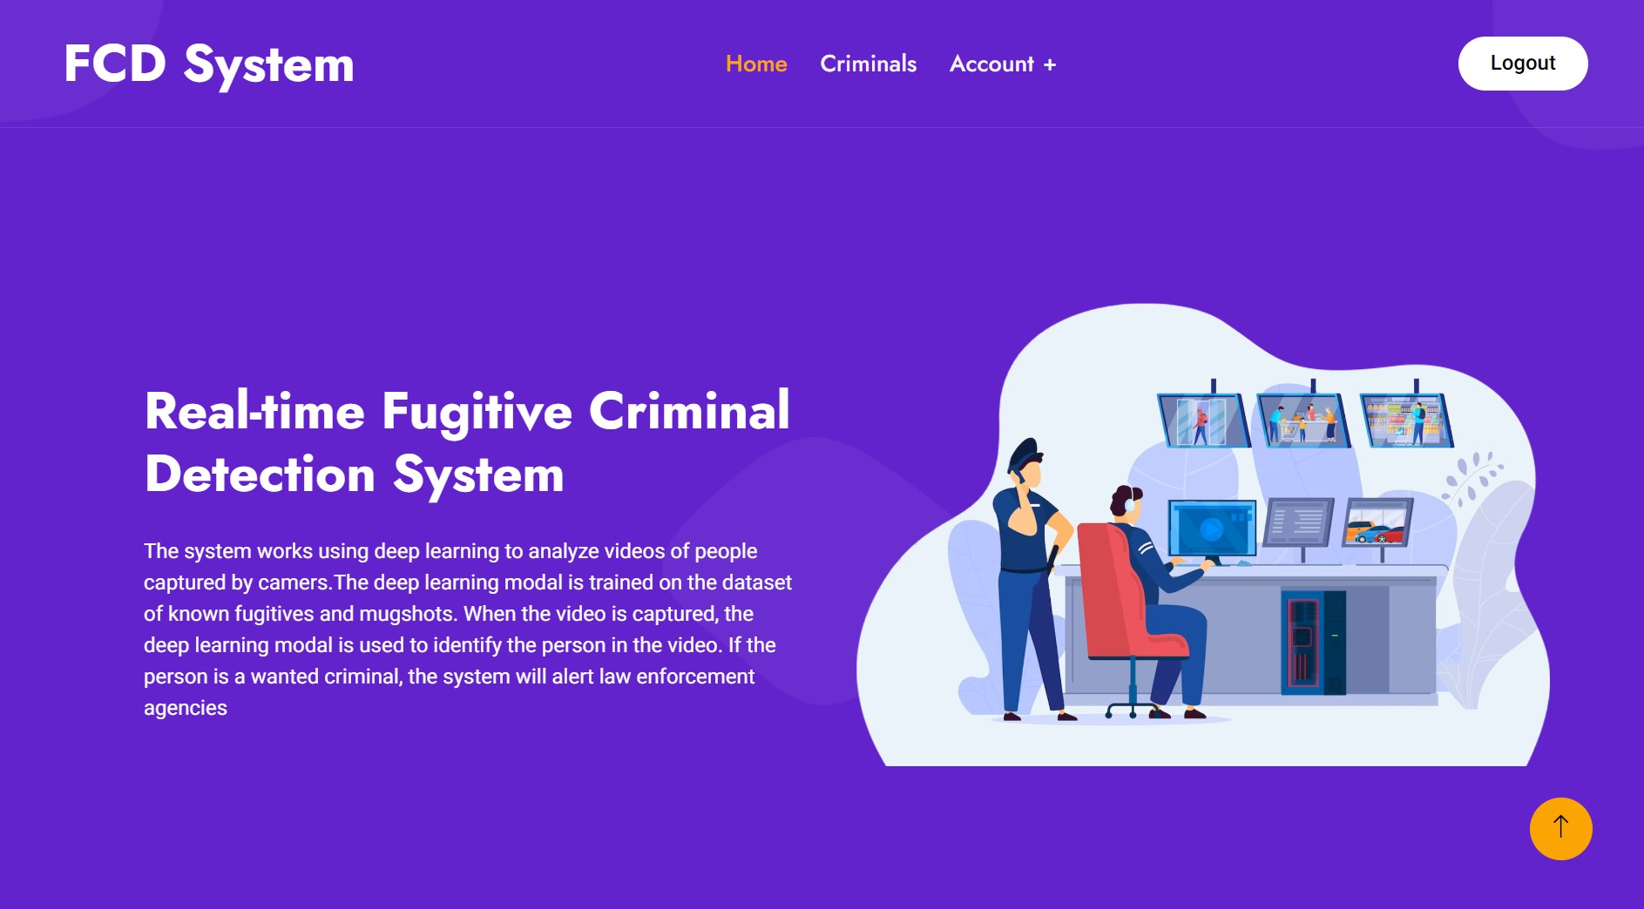
Figure 29:User Dashboard

4.5.12 Fugitive Criminal Page
Figure 30 Represent the Demo presentation of Fugitive Criminals list page.
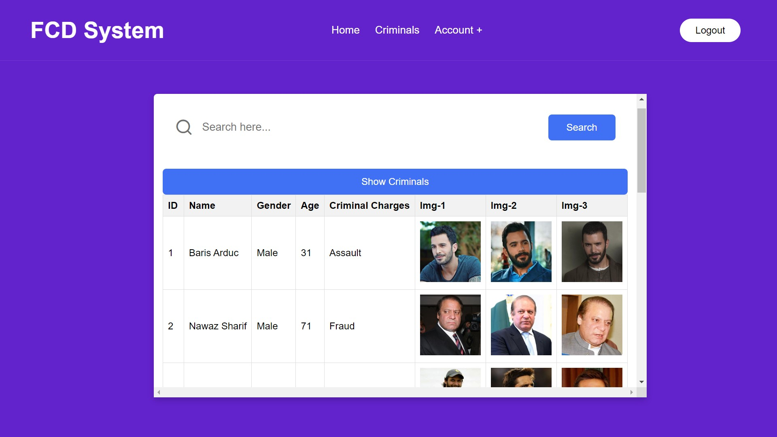
Figure 30:Fugitive Criminal Page

4.5.13 User Reset/Change Password and Email
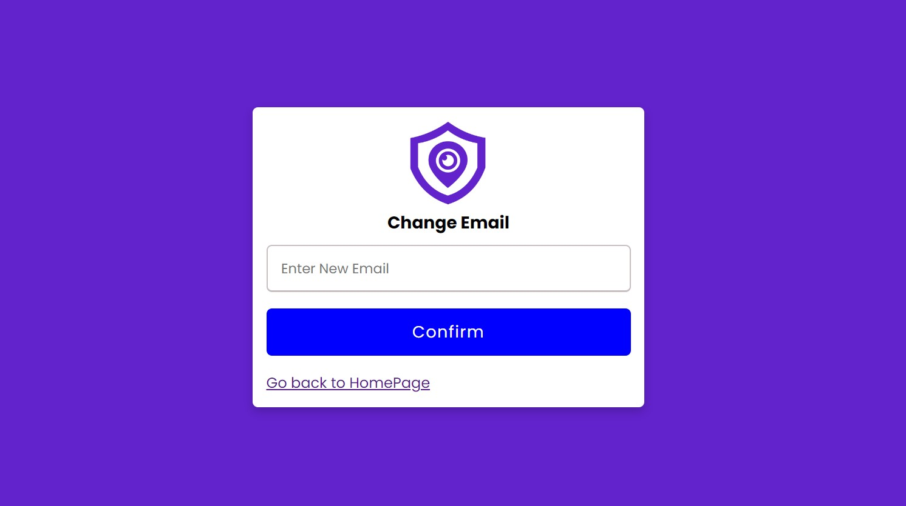
Figures 31 and 32 Represent the Demo presentation of User Reset/Change Password and Email page.
Figure 31:User Change E-mail

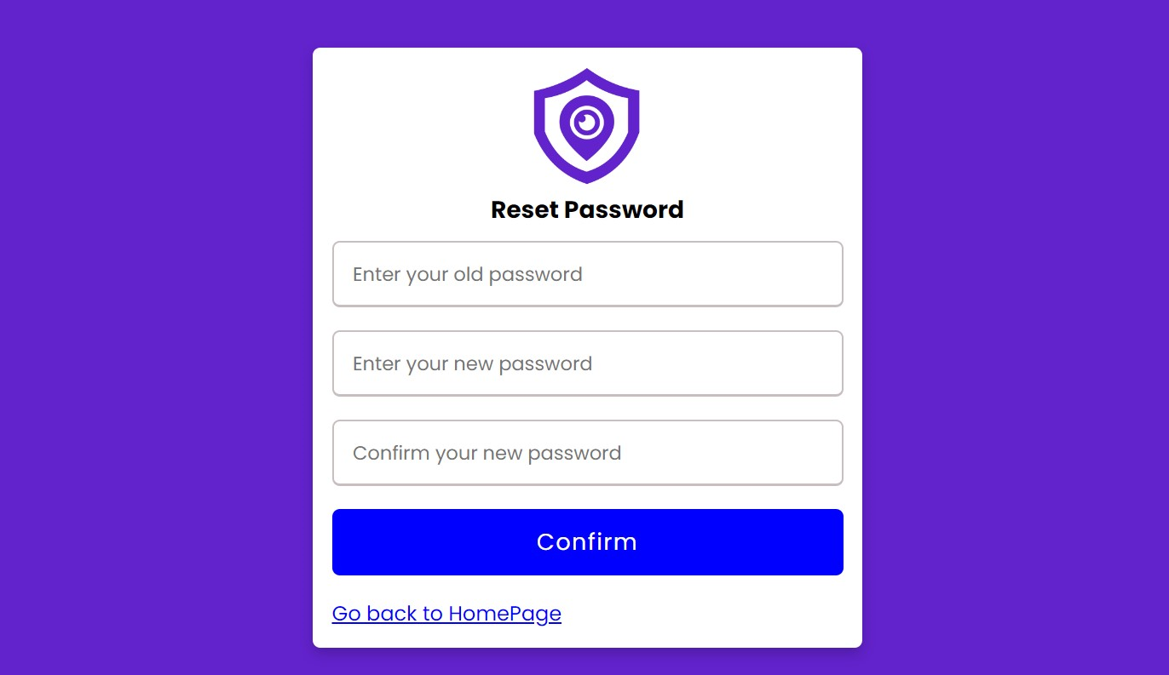
Figure 32:User Reset/Change Password

4.6 Summary
In this chapter, we have discussed all the methods that we have used in the development of our project including the implementation, hardware, and software requirements. We have also discussed the incremental model that we have used as a process model during the development of the document processing system. Analysis methodology is the activities that define software development as a software development process. This is a software process. The four main activities in this process are software specification, software design and implementation, and software validation.

Chapter 5

SYSTEM TESTING
In this chapter, we will discuss the testing phase of the developed application in various ways to know how effective and efficient the website is. The process of running an application or program with the intention of finding errors and whether the website is meeting the user's needs. It can also be defined as the ability of a program to achieve desired or desired results.
System testing is a level of testing that validates a complete and fully integrated software product. The purpose of the system test is to review the end-to-end system specifications. Typically, software is only one element of a larger computer-based system. Ultimately, the software is interfaced with other software/hardware systems.
System testing is a series of various tests with the sole purpose of using a complete computer-based system. Software testing is the process of evaluating the functionality of a software application to determine whether the developed software meets specified requirements and to ensure that defects are eliminated. has been given. Indicates that the product is defect free to produce a quality product.
Software testing ensures that testing is done correctly, and that the system can be used. So, the system is ready to use. Testing provides good coverage of the software being developed and good coverage means that testing is done to cover the various areas of the software including the functionality of the application, the application along with the OS of the machines. Contains compatibility checks on which it is installed, performance testing procedures to test the performance of the application and load testing to ensure that the system is reliable and should not crash or block when the software is in use. Shouldn't be a problem.

5.1 Objective testing
Software testing has different goals and objectives. Software testing has different goals and objectives. The major objectives of software testing are as follows: To find the defects that may be introduced by the programmer while developing the software. Gaining customer confidence and providing information about transport services. An objective test is a test in which the user looks at different services and thus can send messages for any of the services. Objective tests are popular because they are easy to employ and provide a solid result.

5.2 Usability Testing
Usability testing is a method used to evaluate how easy a website is to use. Tests are conducted with real users to gauge how easy it is for users to reach their goals. Usability testing refers to testing or testing a service with representative users. Typically, during a test participants attempt to complete simple tasks while observers watch, listen, and take notes. Its purpose is to identify any usability issues and to determine and record tester satisfaction with the services. The primary purpose of usability testing is to collect data needed to identify usability issues and improve website design. Even the best web design and development teams can benefit from usability testing because the tests identify trouble spots for users and areas where they get stuck or confused. During usability testing we
- Find out how satisfied testers are with our website.
- Identify changes needed to improve customer care and satisfaction.
- Analyze the performance to see if it meets the usage objectives.
The system is user-friendly and easy to use. Everyone can use it easily. Some recipes are configured and check system usage.

5.2.1 Content
- Content should be easy to understand. There should be no grammatical or spelling errors.
- Menus, buttons, or links to different pages should be the same and visible on all pages.

5.3 Software Performance Testing
Performance testing is generally a testing practice performed to determine how a system performs in terms of responsiveness and stability under a specified workload. Performance testing, a subset of performance engineering, is a computer science practice that seeks to establish performance standards in system implementation, design, and architecture.

5.3.1 Testing performance types
- Load testing is the simplest form of performance testing. A load test is usually performed to understand the behavior of a system under a specified expected load.
- Stress testing is commonly used to understand the upper limits of capacity within a system. This type of test is performed to determine the robustness of the system to extreme loads and helps application administrators determine that the system will perform adequately if the current load exceeds the expected maximum.
- Spike testing is done by suddenly increasing or decreasing the load generated by many users and observing the behavior of the system. The goal is to determine if performance suffers, the system will fail, or if it will be able to handle dramatic changes in load.
- Rather than evaluating performance from a load perspective, tests are designed to determine the effects of configuration changes in system components on system performance and behavior. A common example is experimenting with different load balancing methods.
- Isolation testing is not unique to performance testing but involves repeating the test process that resulted in a problem in the system.

5.4 Compatibility Testing
Compatibility testing is a type of software testing that determines whether your software can run on different hardware, operating systems, applications, network environments or mobile devices. Compatibility testing is a type of passive testing.

5.4.1 Types of Compatibility Tests
- Hardware
- Operating Systems
- Software
- Network
- Browser
- Devices
- Mobile
- Versions of the software

Now investigate the types of compatibility testing.
- Hardware: It tests software for compatibility with various hardware configurations.
- Operating Systems: It checks your software for compatibility with different operating systems like Windows, Unix, and Mac OS etc.
- Software: It makes your developed software compatible with other software. For example, MS Word application should be compatible with other software like MS Outlook, MS Excel etc.
- Network: Assessment of system performance in various parameters like bandwidth, operating speed, capacity network. It also checks applications in different networks with all the parameters mentioned earlier.
- Browser: It checks the compatibility of your website with different browsers like Firefox, Google Chrome, and Internet Explorer etc.
- Devices: It checks the compatibility of your software with various devices like USB port devices, printers and scanners, other media devices and Bluetooth.
- Mobile: Testing your software is compatible with mobile platforms like Android etc.
- Software Version: This is verifying the compatibility of your software application with different software versions. For example, check your Microsoft Word for compatibility with Windows 7, Windows 10.

5.4.2 How to do Compatibility Testing
- The initial step in compatibility testing is to define the set of environments or platforms on which the application is expected to operate.
- Tester should have sufficient knowledge of platforms/software/hardware to understand expected application behavior under different configurations.
- The environment needs to be configured for testing with different platforms, devices, networks to check if your application runs well under different configurations.
- Report a bug. Correct the defects. Test again to confirm error correction.
The most important use of compatibility testing is to ensure that developed software works under different configurations (as defined in the requirements document). This testing is necessary to check whether the application is compatible with the client's environment.

5.5 Load Testing
Load testing is a type of passive testing. A load test is a type of software testing that is performed to understand the behavior of an application under a specified expected load. Load testing is performed to determine system behavior under both normal and peak conditions. Load testing is one of the various types of performance testing that determines system performance under real-time load conditions. It is mainly used to ensure that the application performs satisfactorily when many users try to access or use it at the same time.
- Load testing can be done under controlled lab conditions to compare the capabilities of different systems or to accurately measure the capabilities of a single system.
- Load testing involves simulating the real-life user load for the target application. This helps you determine how your application behaves when your application hits multiple users simultaneously.
Load testing differs from stress testing, which assesses the extent to which a system is subjected to heavy workloads or when some of its hardware or software is compromised.

5.6 Security Testing
Security testing is a type of software testing that uncovers vulnerabilities, vulnerabilities, vulnerabilities in a software application and prevents malicious attacks by intruders. The main purpose of security testing is to identify the threats in the system and measure its potential vulnerabilities, so that the threats can be countered, and the system cannot stop working or be exploited. It also helps to detect all the possible security threats in the system and helps the developers to solve the problems through coding. According to the Open-Source Security Testing Methodology Manual, there are seven main types of security testing. They are defined as:
- Vulnerability Scanning: This is done by automated software to scan the system against known vulnerability signatures.
- Security scanning: This involves identifying network and system vulnerabilities, and subsequently providing solutions to mitigate these risks. This scanning can be done for both manual and automatic scanning.
- Penetration Testing: This type of testing simulates a malicious hacker attack. This testing involves analyzing a specific system to check for potential vulnerabilities in an external hacking attempt.
- Risk Assessment: This assessment involves analyzing the security risks observed in the organization. Risks are categorized as low, medium, and high. This assessment recommends controls and measures to reduce the risk.

5.7 Installation Testing
Installation testing is done to check whether the software has been installed correctly with all inherent features and that the product is working as expected. Also known as implementation testing, this is the final stage of testing before the end user has their first interaction with the product.
A few points need to be checked before testing the installation:
- The installation should be run in a default location and should be presented to the user with a default location with which the user may be able to change the default location.
- Verify that user should be able to install software from different locations like network, online installation.
- To verify that Installer.exe is calculating the disk space required to successfully install the application before installing the application.
- Verify software installation on multiple platforms. Before doing so, you must verify the supported list of platforms.
- Confirm this successful "silent installation". Silent installation messages are not displayed on the UI during the installation process, all messages are added to log files and used as input to the installation process based on incoming messages.
- Verify if the user is presented with an interactive installation, GUI screen and requires the user to provide input parameters for the installation. It is mainly used in product installation.
- Verify that after successful installation of the software it functions as described in the specification document and meets the user's requirements.
- Check all pre-installed files and registry entries to see if the software application is not installed or not.
- Verify that the user can uninstall or repair the software application.

5.8 Test Cases
A test case is a set of actions performed to verify a particular feature or functionality of your software application. A test case consists of test steps, test data, preconditions and postconditions that are developed for a specific test scenario to verify any requirement. A test case is a specification of inputs, execution conditions, test procedures, and expected results that describe the tests to be performed to achieve a specific software testing objective, such as a specific program. Using a route or verifying compliance with a specific requirement. As shown in Table 5.
Table 5:Test Cases
Test Cases | Objectives
1 | To make sure the admin can easily manage user accounts.
2 | To ensure that user rights are properly controlled.
3 | To ensure that the admin can perform all your work.
4 | Make sure admin can easily record and add new services and users.

5.8.1 Test cases of Admin
The Test Cases designed for the admin functionality encompassed various scenarios to ensure the smooth operation and reliability of the admin panel. The tests covered different aspects, including user search, data reset, and user data deletion. For user search, cases were defined to verify the correct retrieval of user data based on various search parameters such as user ID, username, or email. The data reset functionality was tested to ensure that all user data was retrieved and displayed correctly when the "Reset Table" button was clicked. The user data deletion process was meticulously tested to confirm the seamless removal of user data from both the database and the displayed table, without any errors or inconsistencies. These test cases collectively assured the admin panel's accurate functioning, user-friendly experience, and effective management of user data, contributing to the overall reliability of the system.
Table 6:Test Cases of Admin
Test Case | Description | Expected Outcome
1 | User Search with Valid User ID | Retrieve user data with matching user ID
2 | User Search with Valid Username | Retrieve user data with matching username
3 | User Search with Valid Email | Retrieve user data with matching email
4 | Reset Table Functionality | Display all user data in the table
5 | Delete User Data | Remove user data from both the table and the database
6 | Delete Non-Existent User Data | Display appropriate message for non-existent user ID

5.8.2 Software Test Description:
The software testing phase encompasses various aspects of the system's functionality and performance. This phase involves systematically designing and executing test cases to validate the behavior of the software components. The test description outlines the specific procedures and expected outcomes for each test case. These tests cover a wide range of functionalities, including user authentication, real-time criminal detection, search capabilities, data retrieval, display of results, and system responsiveness. The software testing phase ensures that the developed application meets its intended goals, performs reliably, and provides accurate and timely results for criminal detection and user interactions.

5.9 Testing Environment:
Table 7:Testing Environment
Testing Environment | Test ID | Preconditions | Actions | Expected Results | Result
Local Development | T1 | None | Open application in browser | Application loads without errors | Pass
Local Development | T2 | Application installed | Perform user login | User is successfully logged in | Pass
Cross-Browser | T3 | Application accessed | Use different web browsers | Consistent functionality across browsers | Pass
Device Compatibility | T4 | Application opened on various devices | Interact with application | Application adapts to different screen sizes | Pass
Load Testing | T5 | Application ready | Simulate concurrent users | System response time remains acceptable | Pass

Chapter 6

RESULTS AND CONCLUSION
In the realm of the "Web Based Real-Time Fugitive Criminal Detection System Using Deep Learning," the culmination of our efforts brings forth substantial results and insights. Through the meticulous utilization of cutting-edge technologies such as HTML, CSS, Bootstrap, JavaScript, Flask (Python Framework), and YOLOv8 (for model training), we have successfully crafted a robust system capable of real-time fugitive criminal detection. Our methodology's systematic approach led us to effectively preprocess and augment data using Roboflow, resulting in an optimized dataset for training. Leveraging YOLOv8, we trained and validated a deep learning model that exhibits promising accuracy in identifying potential suspects. Our comprehensive testing procedures encompassed usability, security, compatibility, and performance, assuring the system's reliability and efficacy.
While we have achieved significant milestones in the development of this system, it is imperative to acknowledge certain limitations. The complexity of real-world scenarios, lighting conditions, and diverse environments poses challenges to the model's performance. Despite our rigorous testing, some scenarios may still require refinement. However, these findings propel us toward further research and development, exploring enhancements in model training, data diversity, and hardware optimizations.

6.1 Presentation of the findings
Our project unveils a promising technological advancement in the realm of law enforcement. Through a meticulous integration of various tools and methodologies, we have developed a system that showcases the potential to enhance fugitive criminal detection processes. Our project's core objective was to leverage deep learning techniques to create a real-time fugitive identification system. The results highlight the viability of our approach, demonstrating accurate and rapid detection capabilities through the utilization of a YOLOv8-based model. However, it is important to note that while the system shows significant promise, challenges such as varying environmental conditions and potential false positives warrant further exploration. The findings underscore the importance of continuous research and improvement to refine the system's accuracy and applicability in real-world scenarios.

6.1.1 Hardware results
The hardware components we have used in this project have been chosen to be more efficient to achieve the best results. We require the following hardware and specifications to implement and deploy this website.
- The laptop can run a suitable browser.
- The laptop has good processing power.
- Installed RAM: 8.00 GB
- Small dataset hardware recommendations
- Medium dataset hardware recommendations
- Large dataset hardware recommendations

6.1.2 Software results
The software has yielded promising results across various components. The user interface, developed using HTML, CSS, and Bootstrap, provides an intuitive and user-friendly experience for interacting with the system.
The JavaScript functionalities, including real-time updates and dynamic content manipulation, enhance the responsiveness and interactivity of the application.
On the backend, the Flask framework has enabled efficient routing and handling of user requests, ensuring smooth communication between the frontend and the MySQL database.
The data preprocessing and augmentation techniques employed before model training have contributed to improved training results, and the integration of YOLOv8 for object detection has demonstrated accurate identification of potential criminal suspects in real-time video feeds.
The cohesive integration of these software components has led to a comprehensive and functional system capable of detecting fugitive criminals efficiently.

6.2 Discussion of the findings
The project achieved remarkable results in real-time criminal detection. YOLOv8 demonstrated high accuracy in identifying criminals in video streams. The integration of the model with the website gives a user-friendly interface. The analysis confirms the system's success in providing real-time criminal monitoring. Compared to existing methods, deep learning proved superior in accuracy and speed. The system's compatibility with various browsers and operating systems highlights its adaptability. However, scalability and resource constraints with many users are potential limitations. Despite this, the project's findings offer valuable insights into technology-driven law enforcement and security solutions.

6.2.1 Comparison with initial GOAL
Comparing project goal with achieved results highlights the project's success in meeting its objectives. The original aim was to develop a web-based system to detect fugitive criminals. The system accurately detects and identifies individuals of interest in live video streams. The integration of YOLOv8 for object detection, along with HTML, CSS, Bootstrap, JavaScript, Flask, and MySQL, has produced a user-friendly and effective platform. The system's real-time video processing capabilities and compatibility with various browsers align perfectly with the initial project goal.

6.2.2 Reasoning for short comings
This project has been developed keeping in mind the research and development-oriented requirement of the final master project. So, there may be some shortcomings, but we're very proud that we've worked in a very versatile environment, and that we've taken the right step in the right direction, in terms of where technology is going today.

6.3 Limitation
Our project has shown promising results, so it is important to address certain limitations. One significant limitation is the system's reliance on high-quality and well-annotated training data. The accuracy and performance of deep learning models, especially YOLOv8, depend heavily on having diverse and representative criminal images for training. If the training data lacks diversity or contains biased samples, the system's ability to accurately identify fugitives from various backgrounds may be compromised. Additionally, the system's real-time performance can be affected by the computational resources available, leading to variations in detection speed and accuracy on different hardware setups. These limitations highlight the importance of continuous data enrichment, bias mitigation techniques, and optimization strategies to improve the system's effectiveness under various conditions.

6.4 Recommendations
For those looking to advance the "Real-Time Fugitive Criminal Identification System Using Deep Learning," here are some key recommendations:
- It’s vital to expand the diversity and size of the training dataset to improve the system's accuracy and robustness.
- Utilizing data augmentation techniques and ensuring a balanced representation of various demographics can help reduce biases and enhance model generalization.
- exploring advanced object detection algorithms beyond YOLOv8 may lead to further improvements in detection speed and precision.
- Collaboration with law enforcement agencies and legal experts is essential to ensure compliance with ethical and legal considerations when deploying the system in real-world scenarios.
- Continuous research and development efforts should focus on refining system performance, addressing emerging challenges, and keeping up with advancements in deep learning and computer vision technologies.

6.5 Summary
In this chapter we discussed hardware and software findings and recommendations. In which we discussed Real-Time Fugitive Criminal Detection System Using Deep Learning. It is a technology that is used to detect and find fugitive criminals by helping the law enforcement agencies.

6.6 Conclusion
Real-Time Fugitive Criminal Detection System Using Deep Learning effectively fulfills its intended objectives. The system has undergone rigorous development and testing, resulting in a stable and efficient platform. All known issues and bugs have been addressed, ensuring smooth operation. Users, including law enforcement personnel, have found the system highly beneficial and comprehend its advantages fully. This system successfully addresses the challenges it was designed to overcome, aligning with its initial requirement specifications.

Chapter 7

FUTURE WORK
While our Web Based Real-Time Fugitive Criminal Detection System has achieved promising results, there are several avenues for further enhancement and expansion. One potential direction for work involves incorporating deep learning models, such as enhanced versions of YOLO or other algorithms designed for object detection. By introducing these models, we can enhance accuracy and broaden the system’s ability to identify a range of activities and suspects.
Moreover, to enhance the user experience we can refine the system by integrating real-time alerts and notifications. This means incorporating alerts through SMS, email or other communication channels that will provide law enforcement agencies with updates on detected activities. This would enable response times.
In terms of scalability, we can extend the systems capabilities to handle a database of criminals and suspects. Additionally, we can introduce features that facilitate managing and categorizing criminal profiles. We could explore cloud-based deployment options to ensure scaling as the user base expands.
Ethical considerations and mitigating bias are also factors that need attention in the future. It is important to ensure fairness and accuracy across demographics while avoiding predictions. Achieving this will require retraining and fine tuning of the model.
Lastly by integrating real time video streaming analysis and sophisticated behavioral detection mechanisms we can enhance the systems’ abilities in identifying activities beyond simple object detection. These improvements would further solidify its effectiveness in real world scenarios.
To sum up, our project establishes the groundwork for an effective real time system to detect criminals. The suggested future tasks mentioned earlier offer the opportunity to improve the system’s precision, scalability, and ethical aspects. Ultimately this will contribute to advancing law enforcement and ensuring safety.

REFERENCES
[1]Roboflow (Data annotation and augmentation) From https://roboflow.com/
[2] YOLOv8 (Model training and validation) From https://docs.ultralytics.com/
[3] Homepage Design and Front-end From https://www.w3schools.com/
[4] SQL Database Xampp Server 7. From https://www.apachefriends.org/
[5] Designing various container From YouTube https://www.youtube.com/
[6] Bootstrap (For designing and responsiveness ) From https://getbootstrap.com/
[7] Flask, Python Framework (For backend) From https://flask.palletsprojects.com/en/2.3.x/
[8] Dataset Collection Form https://www.google.com/imghp?hl=en&ogbl
[9] Python Interpreter From https://www.python.org/

